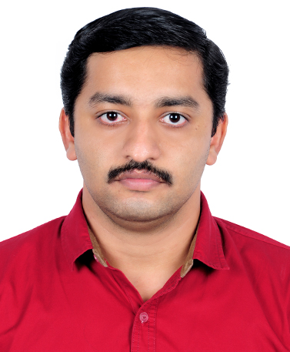
Resume
Albin

Email: albin.381933@2freemail.com

Career Objective
I look forward to associate myself with an organization where there is a scope for contributing and upgrading my knowledge in latest technologies for the development of self and organization.
Strength
- Optimist in life.
- Adapt in dealing with situations in effective manner.
- Able to lead and organize multiple tasks as its prior.

Key Roles
- Ability to communicate with hospitality.
- Committed to provide excellent service
- Adapt to anticipate technology needs and provide swift quality service
- Enhance customer satisfaction through suggestive and upselling
- Willing to take challenges and work as a team for growth of organization

Qualification
- Higher Secondary School-Parumala
- Secondary School-Parumala

Professional Qualification
- Diploma in computer engineering
- Diploma in Hardwearing & Networking
Professional Experience
- Knowledge of on system’s engineering and technical support.
- Knowledge of assemble, disassemble and troubleshooting computer systems
- Knowledge of troubleshooting and managing, Networking LAN & WAN
- Knowledge of updating application software’s, system software’s, and anti-viruses etc
- Knowledge of installing, troubleshooting and managing Windows’ os
Achievements
- Certified in’KELTRON’ COMPUTER HARDWARE DIPLOMA
- Certified in CCNA
- Currently working in Micro sense networks limited as helpdesk executive in Taj hotels present 3years
Passport details
- Date of Birth : 27-5-1990
- Place of Birth : Angadi Ranni, Kerala
- Place of Issue : Trivandrum
Personal Information
- Age : 27
- Sex : Male
- Date of Birth : 27/05/1990
- Marital Status : Single
- Nationality : Indian
Hobbies
- Listening Music.
- Traveling
Languages
- Speak, Read& Write : English, Malayalam.
- Speak : English, Malayalam, and Tamil
Declaration
I hereby declare that the above furnished information is true as best of my knowledge.

