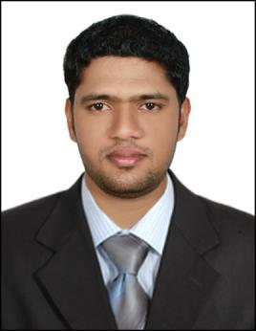
JAMSHEED

E-mail: jamsheed.381945@2freemail.com

Career Objective

To seeking a challenging career by occupying a suitable position as DRIVER for utilizing my organizational skills and experience to contribute towards the progress of organization and at the same time have the professional growth and development of my career.

Personal Profile

- Hard working and dedicated.

- Sincere and result oriented.
- Can work under pressure with time bound performance.

- Easy adaptability to situations.
- Good communication skills

EDUCATIONAL QUALIFICATION

- Higher Secondary

TECHNICAL QUALIFICATION.
- Diploma in Multi Media

( Adobe Photoshop, Adobe Illustrator, Coral Draw, Video Editing)
Driving Licence :

- Holding UAE valid Light Duty Driving issued from Ajman on 16.10.2012

Languages Known:

- English, Arabic ,Hindi and Malayalam

Work Experiences

1- Working as a Driver in FAST WAY EXPRESS COURIER in Dubai since 2016 to till the date

2- Worked as a Driver Cum Graphic Designer in BELAISHA ADVERTISING & PUBLISHING in Ajman, for a period of 7 years.

Personal Details
Date of birth & age |  | : 11.04.1987
Gender |  | : Male
Nationality |  | : Indian
Marital Status |  | : Married
Visa status |  | : | On employment visa

I sincerely hope that my application will receive your kind attention and I am most anxious that an opportunity for an interview is given to me at your earliest convenience.

