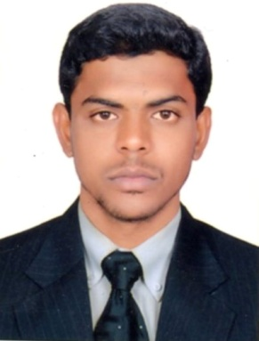
ABDUL R’ESUME

E-mail:- abdul.381951@2freemail.com

CAREER OBJECTIVE

To be part of a progressive company where my expertise and performance with higher responsibilities and challenges would make a valuable contribution to the ongoing success of the organization and my professional growth for a long term win – win understanding.

SKILLS

• Self-motivated individual capable of taking ownership and working independently. | • Hardworking & efficiently proficient also deals effectively with conflicts.
• Customer relation. | • Reliable work ethics & adheres to policies and procedures.
• Ability to listen. | • Possess good relationship building and interpersonal skills.
• Ability to develop and build within the Team with a proactive and enthusiastic approach. | • Excellent planning and organizing skills and a organizing skills & a very good team player.
PROFESSIONAL EXPERIENCE

•Organization Name (INDIA) : NDSL SUGAR LIMITED
•Organization Name (UAE) : INDUSTRIAL MATERIAL SUPPLY,FZCO Jebel Ali, Dubai.
•Designation : Sales Co-ordinator (UAE Feb 2016 to Jan 2017)
•Designation : Store Keeper (INDIA July 2010 to Aug 2014)

RESPONSIBILITY
- Sending Quotation as receive email from the customers, checking the availability of the said material from the Warehouse Operation.
- Receives and inspects all incoming materials and reconciles with purchase orders; processes and distributes documentation with purchase orders; reports, documents and tracks damages.
- Ships cancelled and damaged items back to vendors as appropriate.
Preparing the total account for the sending of goods.
- Maintains the warehouse, records area and stores area in a neat and orderly manner.
- Fills supply requisitions; assists buyer to order adequate merchandise and supplies delivers orders to faculty and staff.

EDUCATIONAL CRENDENTIALS

- Bachelors of Science( Maths, Physics and Computer Science).
- Bachelor Science from Osmania university- Year 2009.
- Board of Intermediate.(Maths, Physics and Chemistry).
- MPC from the Board of Intermediate Education 2001-2003.
- S.S.C - Year of passing Year – 2001.

TECHNICAL SKILLS

- MS – Office (Outlook, Word, Excel & PowerPoint).
- Web Technology.
- Windows.
- Focus, Tally.

STRENGTHS

- Quick learner.
- Willing to learn new things.
- Flexible under any kind of environment.

PERSONAL DETAILS

- Name:- ABDUL
- Maritial Status:-Single
- Date of Birth:- 4TH May 1986.
- Language Known:- English, Urdu and Hindi.

DECLARATION

I declare that the above facts given by me are true to the best of my knowledge and belief.

