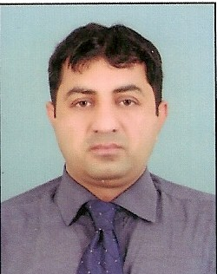
NADEEM
nadeem.381958@2freemail.com
Visa Status: Visit Visa

PROFESSIONAL SUMMARY:

Dedicated professional with hands-on personnel management experience and business related academic knowledge that blends seamlessly into a position such as Human Resources Assistant Manager. Total 5 years’ Experience under HR & Administration departments. I enjoy the working with people and have confidence when confronted with difficult situation. Always up for a challenging, I am seeking an employer rewards based on performance and competence and notice the desire and ability to succeed.

CAREER SKILS:

HR Operation: To manage the overall day to day operations of the department and responsible for the strategic planning of the Human Capital Management.
Performance Management: Ensure timely & fair performance appraisals to be conducted per year.
Recruitment & Selection: To ensure timely recruitment as per approved from Management, ability to build a network of relationships within the organization as well as with other organizations and prospective employees.
Administration Support: To manage team issues and concerns during shift and report any incident to the Management as required, properly enter the unresolved problems in system or verbal to communicate to the senior management.
HR Policies design and Implement: Implement the HR policies internal the departments.

PROFESSIONAL EXPERIENCE

Al-Amal Medical Center LLC Abu Dhabi UAE as “Assistant Manager” (HR & Administration department) from Feb 23, 2016 to Feb 22, 2018 (contract finish)

Major Responsibilities are as under HR & Administration:

- Maintains Human Resources records by recording new hiring and tracking vacation.
- Orients new employees by providing orientation, reviewing company policies.
- Prepared and apply documents Human Resources actions by completing and renewal like new visas and Haad License (Doctors, Nurses and Pharmacist).
- Updates job knowledge by participating in educational opportunities, reading professional publications.
- Provides job candidates by screening, interviewing, and testing applicants, notifying existing staff of internal opportunities, maintaining personnel records, obtaining temporary staff from agencies.
- Assist the Administration Head to maintain a proper quires medical Center and pharmacies and tracking report for the all departments.
- Assist on any ad-hoc tasks as required by the Management.
- Maintain a proper and user-friendly filling and document control system for recording and tracking of all documents.
- Daily check internal department (Doctors, Nurses, other office staff) issue and report to Management.
- Provide full admin support to the all departments related Medical Center & pharmacies Issues.
- Full support to maintain and purchasing new drugs related to pharmacies.
- Maintain barcode system and Stock manage in the pharmacies and full support pharmacist regarding any issue.
- Daily Report to Higher Management (General Manager & DGM) regarding any issue.

Chagatai’s Lahore Lab (pvt) Ltd Lahore Pakistan as “Assistant Manager” (Human Resource department) from June 2013 to Feb 2016 (Shift UAE)

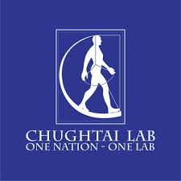
Major Responsibilities are as under HR department:

- Assist with day-to-day HR operations and functions.
- Provide clerical and administrative support to Human Resources executives.
- Compile and update employee records (hard and soft copies)
- Review & finalized payroll of employees and take approval from CEO to transfer
Salaries in Bank Account
- Monitor all department and attend meetings with CEO
- Receive emails from departments and out of city centers and solve problem immediately.

PROFESSIONAL QUALIFICATION

- Post-Graduation

MBA (Master of Business Administration)
(Sept 2012-Aug 2015)

COMPUTER COURSES June 2000 to August 2001

One-Year Computer Course (DCS)

- Working Knowledge of MS Word, MS Excel & MS PowerPoint
- Working Knowledge of Oracle Base Accounting Software
- E-Mail, Net Browsing, Searching

INTERNSHIP

- 3 Months Internship in United Bank Limited (UBL) Sargodha Punjab Pakistan
- 3 Months Internship in the Bank of Punjab (BOP) Lahore Punjab Pakistan

ACHIVEMENT

British English Certificate

- 6 Months British English Language Course (Sept 2009-Feb 2010)

PERSONAL INFROMATION

Date of Birth 11-09-1983
Driving Lenience UAE Yes

REFERENCE

Reference will be upon on request

