CURRICULUM VITAE  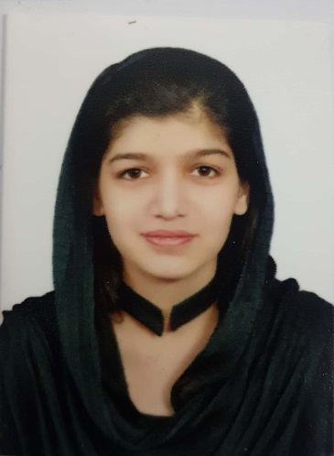  SAMRA  Samra.382070@2freemail.com  - Nationality: Pakistani  - Sex: Female  - Marital Status: Single  - D.O.B 25-JUN-1997  Visa Status: Visit Visa  Visa Expiry: OCT 2018  Languages Known:  - English, Urdu, Panjabi | Career Objectives  Customer-focused service professional with strong in-bound and out-bound contact center experience and expert knowledge of cross/up selling.I have extensive work experience in office environments, giving me varied skills and the ability to work with many different types of people. I believe I could fit easily into your team. I'm flexible, quick to pick up new skills and eager to learn from others. I'm keen to work for Organization with a great reputation and high profile.  Strength  I am an enthusiastic and dedicated professional with extensive experience across all areas of customer service. An exceptional leader who is able to develop and motivate others to achieve targets, I can demonstrate a strong ability to manage projects from conception through to successful completion. A proactive individual with a logical approach to challenges, I perform effectively even within a highly pressurized working environment.  Academics  - Master in Commerce (M.A) (continue)  GC university Faisalabad  - Bachelor in Arts (B.A)  GC university Faisalabad  - Inter in Commerce (D.Com)  Board of Technical education Lahore  Personal Attributes  - Team Player  - Adaptive to change  - Self-motivated  - Result oriented  - Consistent on duty  - IT and communication expertise  Professional skills  - Extensive experience in retail environment.  - Excellent vocabulary skills  - Coaching and friendly style of management.  - Great sales and customer service skills  - Excellent time management skills  Computer Competence  - Proficient in all MS Office applications like MS Excel, MS Power

Work Experience (Pakistan):
• Company: RCG (Faisalabad)
Position held: Assistant Retail In charge & Store VM In charge
Date: 23rd FEB 2016 to 10-JUL-18
Major responsibilities:

- Manage Store Operations.
- Manage Staff strength & Other Staff Operations.
- Manage Stock.
- Deal With new Parties (Vendors/Customers).
- Manage Section Strength.
- Manage Sale Targets.
- Store V.M.
- Event Management.
- Planning for Dead stock sale.
- Plane Discount Sales With Retail Manager & Other Team members.
- Plane Tanning for Sales Staff.
- Make Comparison with Market Rates
Company: RCG (Faisalabad)
Position held: Accountant
Date: 10 JUL 2015 to 29 January 2016
Major responsibilities:

- Preparing Vouchers (JNV,BPV,TRF etc.)
- Reconcile Accounts With Parties (More then 1000).
- Reconcile Account With Bank( More then 100).
- Reconcile Credit Card Transaction With Bank.
- Managing Cashier Ledgers
- Managing Petty Cash.
- Arrange Online for Parties.
- Making Salary Sheet on Month End.
- Maintaining employee Salary advance & Loan Account.
Company: Zainab boutique Center (Faisalabad )
Position held: Assistant In charge Retail
Date: 25 January 2013 to 28 June 2015
Major responsibilities:

- Manage Staff strength & Other Staff Operations.
- Manage Stock.
- Deal With new Parties (Vendors/Customers).
- Manage Section Strength.
- Manage Sale Targets.
- Store V.M.
- Event Management.
- Planning for Dead stock sale.
- Plane Discount Sales With Retail Manager & Other Team members.
- Plane Tanning for Sales Staff.
- Make Comparison with Market Rates

Marketing:

- Managing links with other companies
- Conduction of seminars
- Arranging and organizing different in house and out of the campus functions
- Participation and arrangements in Expo
- Managing links with suppliers of Marketing Material

SIDE-LINE INTERESTS
- International politics
- World economy and Capital markets
- Business and finance communities
- Social networking
- Reading books

