RISHABH
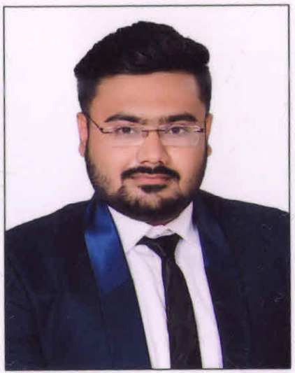

B.COM, CPT(CA),FINANCIAL ADVISOR

E-mail: rishabh.382073@2freemail.com

CAREER OBJECTIVE

- Contribute towards the achievement of goals of organization.
- Derive satisfaction from my work and input my best to apply my skills and knowledge.
- Ensure every professional activity as value addition for client, organization and myself.
- Review work and behaviors of the client that may improve outcomes and results.

CAREER PROFILE AND WORKING EXPERIENCE

•FEDERAL BANK PVT. LTD; CIVIL LINES, ALLAHABAD.
(Worked as a FINANCIAL& BANKING ADVISOR for 12 months from JUNE 2015 TO MAY 2016)

•ZUHAIR ENTERPRISES PVT. LTD; ALLAHABAD.
(Working as an Accountant from July 2017)

ACADEMIC DETAILS

Standard | Board / University | Year
B.Com | UNIVERSITY OF ALLAHABAD | 2015
XII | CBSE | 2012
X | CBSE | 2010

•Scored a CGPA of 9.4 in Class X.
•Topper of the batch for the session 2010-11 in Class XI.
•Received Proficiency Award for being the Business Studies Topper for the session 2010-11 in
Class XI.
•Received Certificate Of Merit for Achieving Overall 3rd Rank for the session 2011-12 in
Class XII.
•Received Certificate Of Merit for being the Business Studies Topper for the session 2011-12 in
Class XII.
•Cleared CPT with an Aggregate of 121 Marks in one go.

COMPUTER PROFICIENCY

- Sound Knowledge of MS-Office applications such as Excel, Word & PowerPoint etc.
- Good Knowledge of Accounting and Tax related software and database viz. Tally.

EXTRA CURRICULAR ACTIVITIES AND INTERESTS

- Awarded with Excellent Academic Performance Award by United College.
- Awarded with Certificate of Appreciation for having CENT PERCENT attendance for the year 2010-11 in Class XI.
- Awarded with Certificate of Appreciation for having CENT PERCENT attendance for the year 2011-12 in Class XII.
- Was a proud member of National Cadet Corps (NCC), India.
- Received NCCs A Grade certificate with ‘AYE’ Grade in the year 2009.

LANGUAGES KNOWN

• ENGLISH
• HINDI
•ARABIC (Learning Stage)

PERSONAL PROFILE

Date of Birth - 23rdJune, 1994
Nationality - Indian
Marital Status - Single
Hobbies - Playing Cricket, Cooking, Collecting Antique coins and Currencies.
Traits - Honest, Hard Working, Optimistic, Leadership, Patient, Determined.

