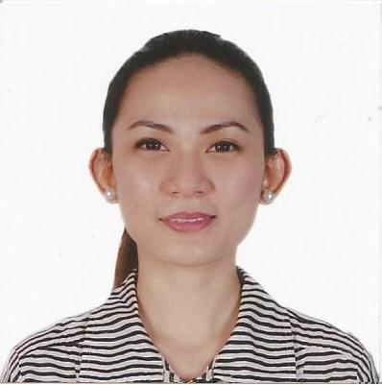
Ms. Patricia

E-mail: patricia.382097@2freemail.com

Objectives
To have a career growth and exercise my skills and knowledge gained from my work experience
Education
Tertiary : Sacred Heart College
BS in Business Administration
Concentration: Management
Deans Lister, Academic Awardee

Secondary: Maryhill College
Honor Student, Journalist

Primary: Lucena East I Elementary School
Valedictorian,
Excellence Awardee ( Florida, USA)
Experience
Department Head Landmark Retail ( The Babyshop LLC )
Mirdiff City Center, Sept 2013- June 2016,
Dubai Mall, July 2016-Aug 2017
Arabian Center, Aug 2017-July 2018 Dubai UAE

Performed the following
- Adheres to all policies, procedures and business ethics codes and ensures that they are communicated and implemented within the team.
- Develops a business plan and sales strategy for the market that ensures attainment of company sales goals
- Maintains accurate record of all sales and activity reports
- Motivates staff in achieving target goal and provides quality customer service
- Monitors department’s inventory and stocks

Store Sales Manager Raffco International Trading Corp. ( Plains & Prints )
Lucena City, Quezon Province, Philippines
2011-2013

Performed the following:
- Devises strategies and techniques necessary for achieving the sales targets.
- Motivates team members to work towards a common objective.
- Maintains and improves relationships with the customers
- Maintains necessary data and records for future reference.

Human Resources Specialist Market Strategic Firm Inc. ( SM Department Store )
Lucena City, Quezon Province, Philippines
2008-2011

Performed the following:
- Conducts recruitment and company orientation
- Handles employee discipline and labor relations
- Facilitates employee movement ( documentation for employee regularization and promotion)
- Handles benefits and compensation of employee
- Other task: facilitates Training Program, HR statistical reports, encoding, coordinates company event.

Skills
- Computer literate – Microsoft Office

Personal Information
- Handles benefits and compensation of employee
- Other task: facilitates Training Program, HR statistical reports, encoding, coordinates company event.
- Date of Birth : March 16, 1987
- Place of Birth: Lucena City, Philippines
- Religion: Catholic
- Gender: Female
- Marital Status: Married
- Age: 31 years old

