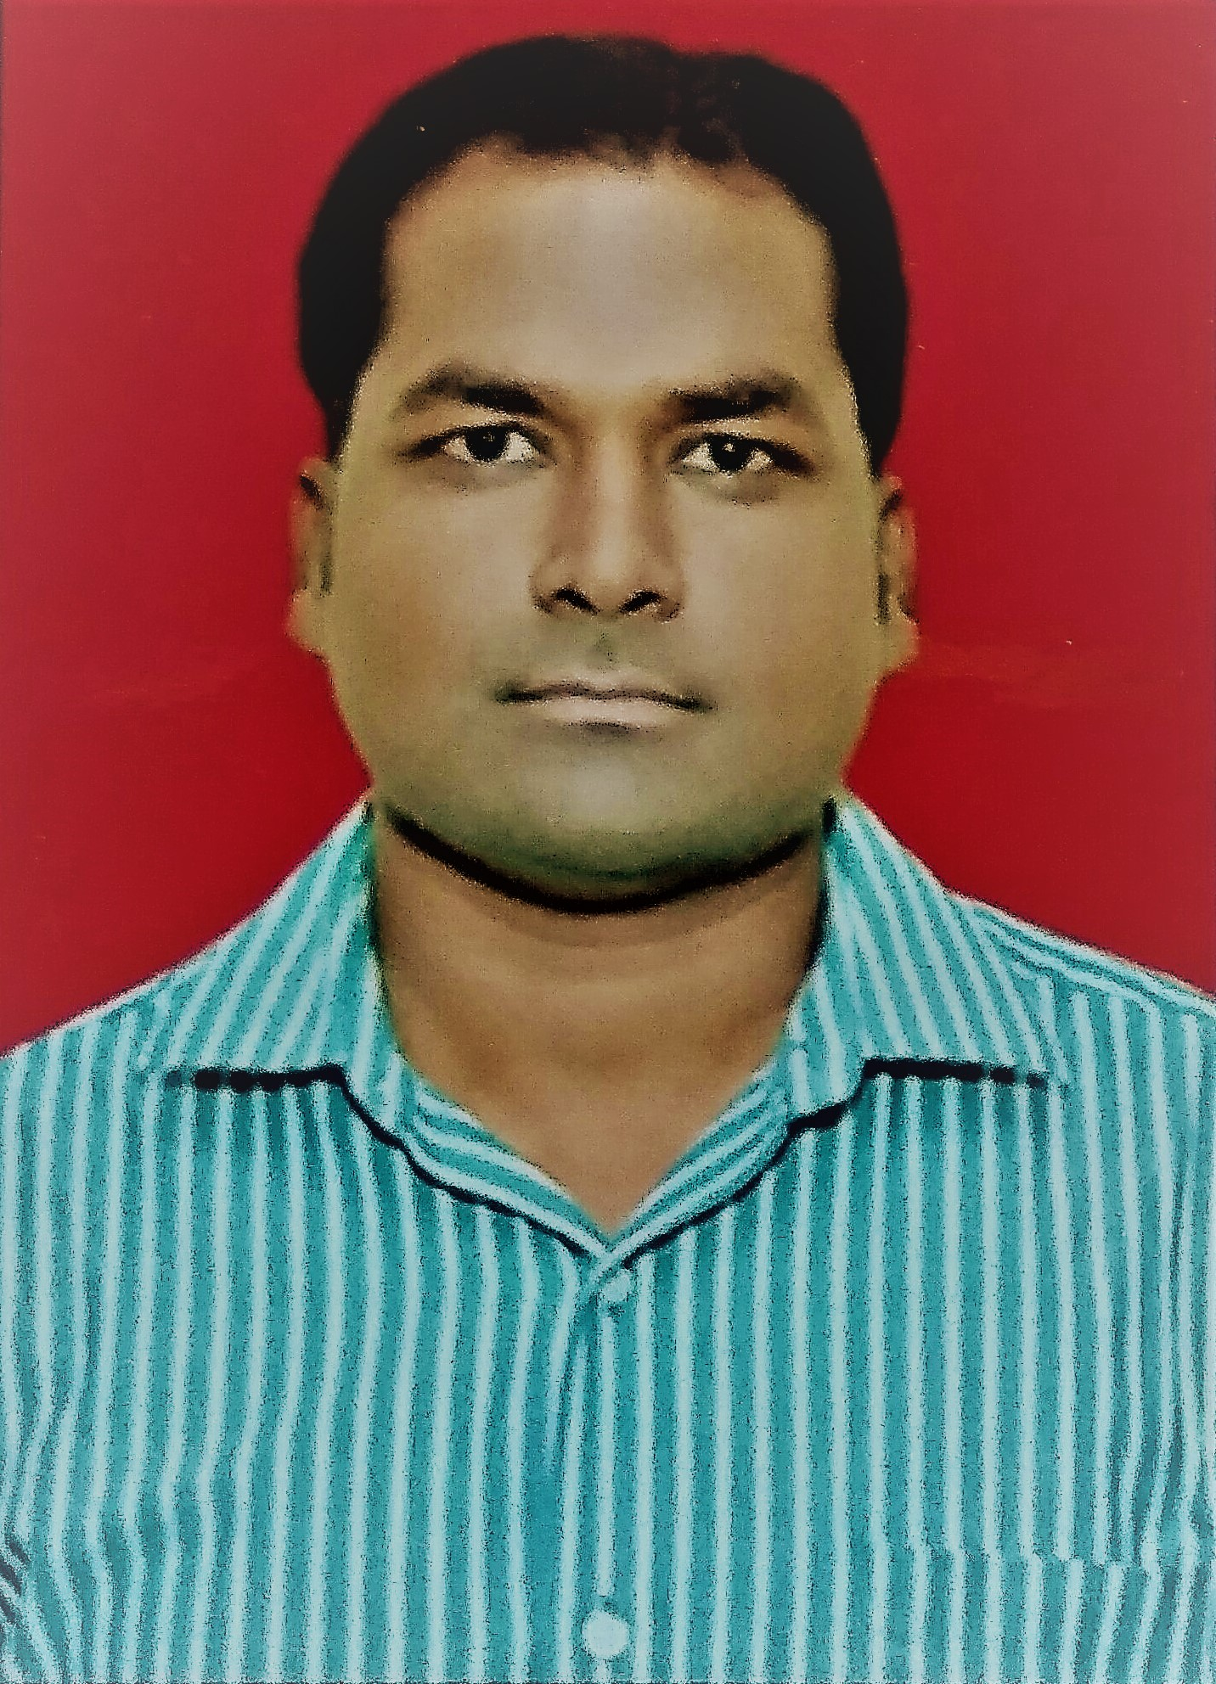
MAHAVEER
E-Mail: mahaveer.382138@2freemail.com

Diploma Electrical Engineer

Professional Profile

- Diploma in Electrical discipline with 10 years of experience in field of Supply, Installation, Testing and Commissioning of Process Instruments.
- Worked with YOKOGAWA India Limited - India (August 2012 to February 2018)
- Worked With Industrial Automation – Kota, India. (July 2007 to July 2012)
- Check, re-view consultant/ customer design and implementing in shop drawings. Co-ordination with the drafting department starting from Plant / Site work until As Built drawing preparation in conjunction with Quality Standards and norms.
- Responsible for site Electrical and Instrumentation works.
- Proficient in installation & commissioning of process instruments i.e. Pressure transmitters, Temperature transmitters, Flow meters, Level instruments, Proximity switches / Sensors, Gas and Liquid Analyser.
- Ensure that the work should complete in time frame with the given specifications.
- Preparation of final close-out documents such as Operation & Maintenance manual, Training manual, Spare part list & Warranty certificates as per Project Contract specification.

Area of Exposure

- Project : Magnetic Flow meter & Liquid Analyser Installation, Testing And
Commissioning
- Position : Electrical & Instrumentation Engineer
- Client : Shriram Fertilisers and Chemicals – Kota
- Duration : February 2013- October 2013
- Installation, testing and commissioning of 14 Nos. Magnetic flow meters and 7 Nos. Liquid analysers at Shriram Fertilisers and Chemicals – Kota.
- Ensure that progress of works is in accordance with construction schedule and as per provided wiring schedule.
- All site works are carried out safely and all staffs are aware of their responsibilities and communicate openly.

- Project : Temperature Transmitters & Pressure Transmitters Installation, Testing
And Commissioning
- Position : Electrical & Instrumentation Engineer
- Client : Oil India Limited-Jodhpur
- Duration : April 2014- September 2014
- Installation, testing and commissioning of 60 Nos. Pressure transmitters and 20 Nos. Temperature transmitters at Oil India Limited-Jodhpur, India.
- All site works are carried out safely and all staffs are aware of their responsibilities and communicate openly. Certify that progress of electrical & Instrumentation works is in accordance with provided and as per plant schedule.

- Project : Pressure Transmitters & Zirconia Oxygen Analyser Installation, Testing
And Commissioning
- Position : Electrical & Instrumentation Engineer
- Client : Adani Power Limited- Baran
- Duration : December 2014- August 2015
- Installation, testing and commissioning of 87 Nos. Differential Pressure Transmitters and 4 Nos. Zirconia Oxygen Analyser at Adani Power Limited-Baran, India and handover the complete operational system to client with recommended spare items, System Manuals and technical documents related to above instruments.

- Project : Vortex & Magnetic Flow Meter and Liquid Analyser Installation, Testing
And Commissioning
- Position : Electrical & Instrumentation Engineer
- Client : Hindustan Zinc limited –Dariba, India
- Duration : January 2016- August 2016
- Installation, testing and commissioning of 25 Nos. Flow meters and 10 Nos. pH and Conductivity Analysers Transmitters with Sensor at Hindustan Zinc limited –Dariba, India.

- Project : Zirconia Oxygen Gas Analyser Installation, Testing and Commissioning
- Position : Electrical & Instrumentation Engineer
- Client : Rajasthan Rajya Vidyut Utpadan Nigam Limited
- Duration : September 2016- April 2017
- Complete Installation of Zirconia Oxygen Analyser system at site and check the complete Installation as per equipment guideline/ Manual and Testing and commissioning of 12 nos. Zirconia Oxygen Gas Analyser at Kota Super Thermal Power Station, Kota, India and provided to customer recommended spare item list for further assistance.
- Project : Supply and Installation of Process Instruments in Thermal Power Plants, Cement
Plants and Fertiliser Industries (Pressure transmitters, Temperature Transmitters,
Flow meters, Level Instruments, Proximity Switches / Sensors, Testing Equipment’s)
- Position : Electrical & Instrumentation Site Engineer
- Client : 2X660MW Adani Power Thermal Power Plant - Baran, Chambal Fertilisers and
Chemicals limited – Gadepan, Shriram Fertilisers and Chemicals – Kota, Shree Cement Limited – Beawar, Ambuja Cement – Rabdiya Vas, Manglam Cement – Modak, ACC Cement – Lakheri
- Duration : July 2007- July 2012
- Responsible for site electrical works which include installation of Pressure transmitters, Temperature transmitters, Flow meters, Level instruments and Fire alarm system.
- Installation Fire Alarm system and communication system for horizontal cabling
- Ensure that installations comply with the detailed construction specification and quality works as per Project standard
- Ensure that progress of electrical works is in accordance with construction schedule.
- Ensure that adequate resources and materials are available on site to suit the project requirements of the construction schedule

- Project : Fire Alarm System Installation, Testing and Commissioning
- Position : Electrical & Instrumentation Site Engineer
- Client : Hindustan Zinc–Agucha, Maiher Cement–Satna & Century Cement - Raipur
- Duration : July 2009 - Dec 2009
- Planning Co-ordination with sub-contractor, installation of Fire Alarm System installation, termination, testing and commissioning, supervising and approving subcontractors work, etc.

INTERESTED AREAS
- Electrical & Instrumentation.

Professional Training

- 22nd May 2006 – 22nd June 2006
Underwent one month Plant Industrial Training on “Power Generation” at “National Thermal Power Corporation Limited (NTPC), Anta-Rajasthan in India.
- 15th November 2008– 16th November 2008
Understanding of Fluid controls Systems at ROTEX Fluid Control System- Vadodara Factory.
- 21st September 2009– 23rd September 2009
Three days training programme on Servicing of Masibus products at Masibus Automation and Instrumentation Pvt. Limited-Gandhinagar.

Academia

- Diploma Engineering (Electrical) 2007
Government Polytechnic College Kota; University of Board of Technical Education, Rajasthan; 67.21%
- 12th from Central Public Senior Secondary School, Kota; Board of Secondary Education, Rajasthan; 63.23%
- 10th from Kota Bal Vidya Mandir Senior Secondary School, Kota; Board of Secondary Education; 75%

IT Skills : Microsoft Windows, Microsoft Excel, Microsoft word, Power Point, Auto Cad.

Personal Vitae

Date of Birth : 20th July 1987
Visa Status : Visit Visa
Nationality : Indian
Gender : Male
Marital Status : Married
Language Known : Hindi, English.

