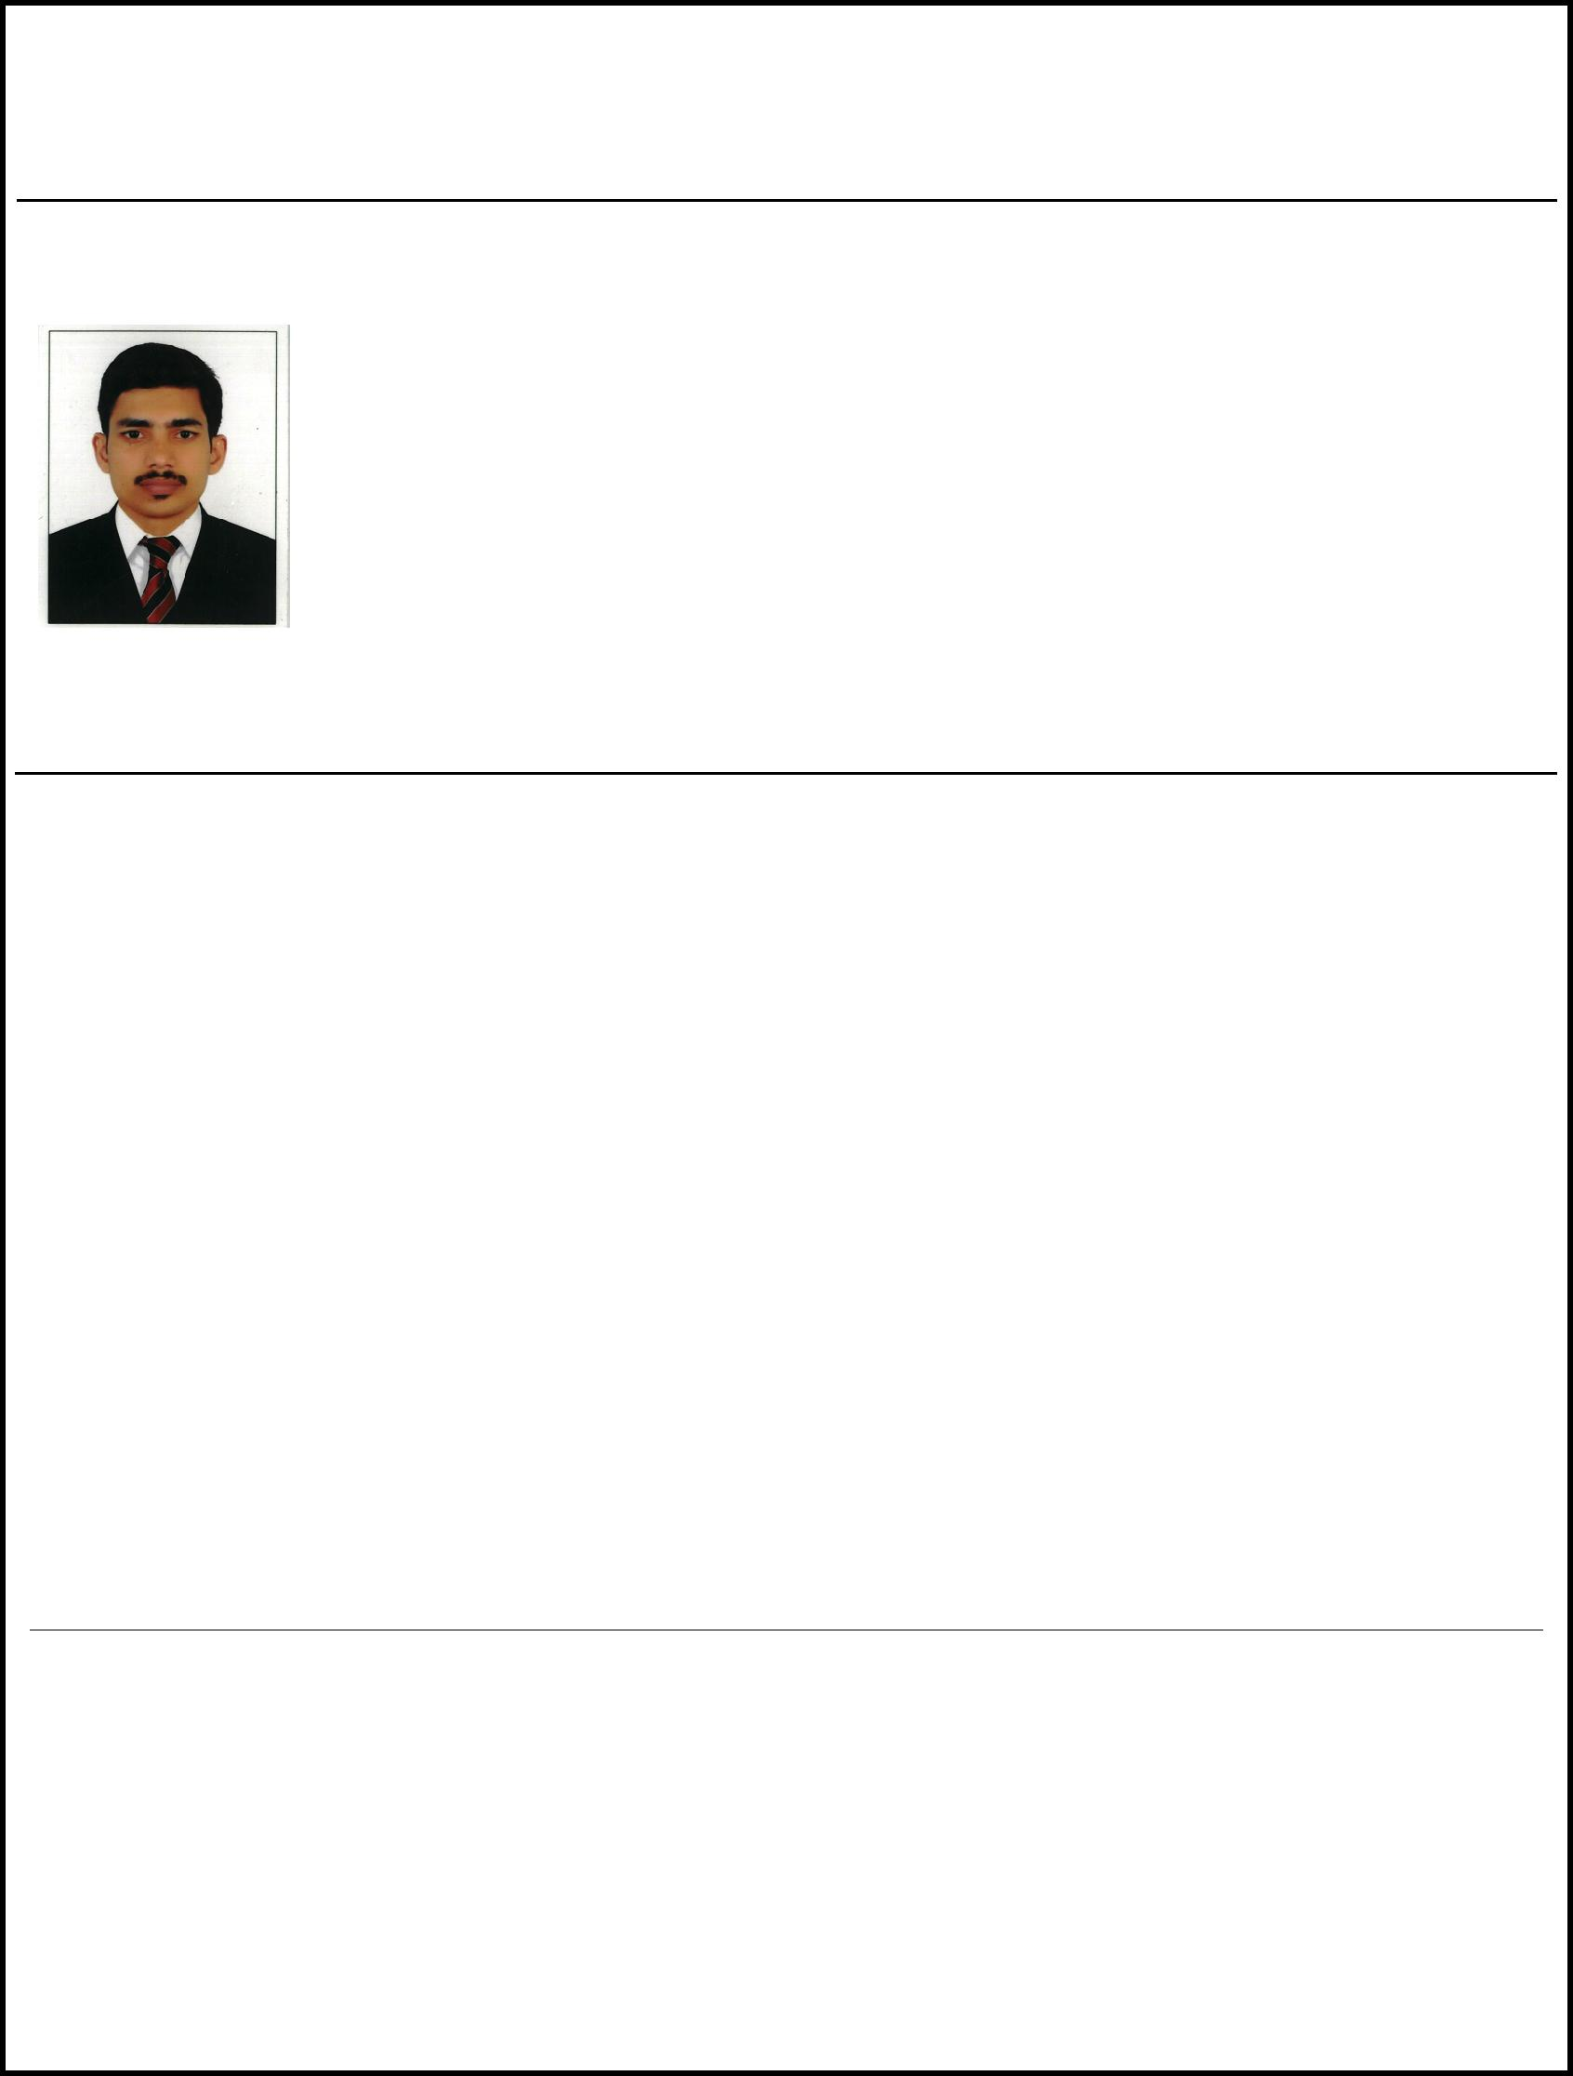
RESUME

Position Applied For: DRIVER

JERIN

8TH OCT 1992,INDIA

Email: jerin.382168@2freemail.com

OBJECTIVE

Reliable and safety- oriented Driver with 9 years’ hands-on experience in light and heavy vehicle driving. Committed to ensuring the safety of passengers, merchandise and vehicle. Excellent problem-
solver who responds quickly in emergency situations. Proven ability to read maps and use GPS systems. Great hand-eye coordination.

SKILLS

- Excellent Handwriting in English.
- Proficient in Microsoft Word, Excel, Power point.

- Technician in Computer Software.
- Familiar with routes, locations and addresses in and around city.
- Able to perform minor repairs on different kinds of vehicles.

- Demonstrated ability to keep the vehicle clean all times.

 | EDUCATION
Diploma in Automobile Engineering | March 2010
Anna University, Tamilnadu.
High School
Vishwa Vidya Matt, Kerala | April 2009

EXPERIENCE

Home Driver
Rijas Aces L.L.C, Dubai

Taxi Driver

Dubai Taxi Driver under RTA with Valid UAE
License

Dec 2017 - Mar 2018

Aug 2016 - Dec2017

Tourist Driver

Celebrate Tours and Travels.

Feb 2010 - Sep 2013

Govt. Driver

Income Tax Department.

Jan 2013 - Jun2016

- Keep the cab clean and maintain hygiene, both internally and externally.

- Take care of the safety of passengers and the vehicle as well.

- Repair the vehicle whenever any minor problem arises.

- Behave properly and in a well manner with all passengers.

- Provide information about local areas to the passengers.

LANGUAGES

- English.

- Hindi.

- Tamil.

- Malayalam

