CURRICULUM VITAE
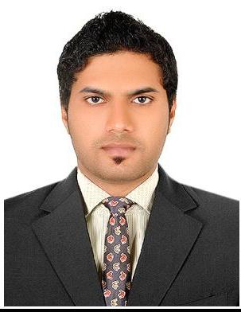

MUSTHAFA | Musthafa.382207@2freemail.com
DUBAI-UAE

CAREER OBJECTIVES:

To lead a challenging career and to work in an organisation, where I can contribute my knowledge and skill for the growth of the organisation, which gives an opportunity for better learning, and excellence in the latest technology.

SKILLS:

- Good communication and presentation skills.

- Strong mental acumen and ability to learn things.

- A positive attitude towards work and working in a team.

- Ability to co-ordinate and complete jobs in time, & efficiently.

- Willingness to learn and take-up new assignments.

- Energetic, dedicated, committed and self motivated to perform & succeed.

- Can work under pressure and meet deadlines.

ACADEMIC PROFILE:

- Higher Secondary Education

- Diploma in Travel& Tourism (Speed Wings Aviation Academy, Cochin )

COMPUTER SKILLS:

- Accounting (Tally)

- Packages : MS-OFFICE

- Uses of Internet & Email.

Major Strengths.
  - Self motivated

  - Team player.

  - Seek to improve efficiency in working level

  - Positive & flexible.

  - Able to grasp new challenges.

  - Excellent relationship management skills

EXPERIENCE:

- Worked as Physical Trainer cum P.R.O ( Nashwan Gym, Al-Qusais-Dubai ) from June 2006 to May 2011.

- Worked as Sales & Marketing Officer cum P.R.O ( Body Tech Nutrition, Al-Qusais, Dubai from June 2011 to July 2014).

- Worked as P.R.O cum Sales in charge ( Al Beed Trading LLC, Dubai ) from August 2014 to December 2014.

- Presently working as Physical Trainer in ( RTA - Roads and Transport Authority Headquarters Dubai, Umm Ramool 2015 January onwards)

Responsibilities.

- Sales & Marketing daily basis.

- Maintain daily Accounts records.

- Sales Administration support and filing

- Maintain & Develop existing customer keep tracking with customer

- Generating good relationship with customer.

PERSONAL DETAILS:
Age and Date of Birth | - 29, 25/05/1986.
Nationality | - Indian.
Languages Known | - Arabic , English, Hindi & Malayalam ( Read/Write/Speak )

Valid UAE Driving License Holder

Received Appreciation Certificate for Good Trainer from RTA Authorities.

