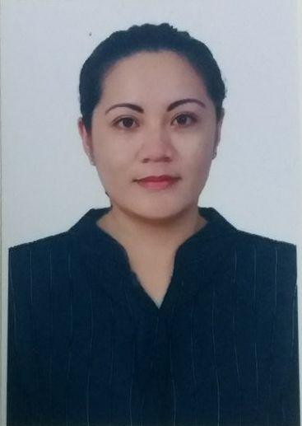
JAZE

AlRigga,Dubai
EmailAddress: jaze.382284@2freemail.com

Objective:Toobtainapositionthatwilenablemetousemyskils,educationalbackground,workexperiences andablitytoworkwelwithpeople.

Capablities:
- ExcelentOrganizationalandCustomerServiceskils
- SalesandMarketingSkils
- Excelentinplanning,detail-orientedandanalyticalprofessional
- Resultdriven,teamplayerwithcommunicationandinterpersonalandintrapersonalskils
- Patient,punctual,resourcefulandenthusiastictoacquiremoreskilsandknowledge
- ComputerLiterate(MicrosoftOfice)

WORKEXPERIENCES:

SALESEXECUTIVE(JAZTIN-Phlippines)

September2017-May2018

Conductingmarketresearchtoidentifyselingpossiblitiesandevaluatecustomersneed.Promotingproducts

throughsocialmedia.Maintainingrelationshipwithcustomersandmeetingthemupforproductpresentation
andclosingdeals.

ESLTEACHER(Private-Thailand)
(November2016-August2017)
Responsiblitiesincludeplanning,preparinganddeliveringlessonstoJapaneseandThaiclients.

CONSULTANT(G.A.M.LegalAliance-Thailand)
September2014-October2016

Responsiblitiesincluderesearch,customerservice,salesandmarketing.Contactinglocalandinternational
clientsviatelephone,email,livechatandfacetoface.Arangingmeetingswithprospectsinorderto

demonstratecompanyservices,negotiatingpricesandclosingdeals.Buildinglongtermrelationshipswithnew

andexistingcustomersandmeetingsalestargetsassetbythesalesdirector.Givingbestadviceandguidance

onhowtoobtainrequireddocumentationtocompletevisaapplicationprocess,providingthecomplete
informationandguidelinestotheapplicantsandcommunicatingwithauthoritiesandtheclient

consistently.Ensuringpaperworksarecompletedefectively.Assistinbookingflightandhotelreservationfor
theclientsandtranslationandlegalizationofdocuments.

RECEPTIONIST(NATURE-Macau)
May2013-February2014

Responsiblitiesincludecompletecustomerservice,dealingwithalinquiries,administeringalreservationsand
cancelationsofguestandprovidinginformationtoguest.

ADMINISTRATIVESTAFF(GOVERNMENTUNIT-Phlippines)
September2010-April2013

Responsiblitiesincludeansweringphonecals,sendingemails,preparingreportsandfinancialdata,requesting

andpurchasingoficesupplies,makingtravelordersandhotelreservation,conductingeventsandtrainingsand

supervisingothersupportstafandcustomerrelations.Performsadministrativedutiesfortheorganization.

SALESREPRESENTATIVE(SOPHIEPARIS-International)
January2009-April2013

Responsiblitiesincludeproductintroductionanddemonstration,promotingproducts,establishingcustomers'
needs,developingandupdatingknowledgeofproductsandmeetingupwithcustomers.

RESEARCHASSISTANT(BENGUETSTATEUNIVERSITY-Phlippines)
April2010-May2010

Responsiblitiesincludepreparingandmanipulatingdatabasesandassistinginpreparationofpresentationsand

manuscript.

SERVICECREW(Phlippines)
January2006-April2008

Responsiblitiesincludeprovidingfoodandbeverageservices,presentingandrecommendingmenu,taking
orders,attendingcustomers’needsprofessionalyandcolectingbils.

EDUCATION:
BenguetStateUniversity,Phlippines
BachelorofScienceinAppliedStatistics-2010

TRAININGSandSEMINARS:
- TrackingSystem
- RecordManagement
- DatabaseUsingStructureQueryLanguage
- EnglishLanguageProficiency

PERSONALDATA:
DateofBirth :June12,1988
Citizenship :Flipino
CivilStatus :Single
Sex :Female

CHARACTERREFERENCES:

(AvailableUponRequest)

