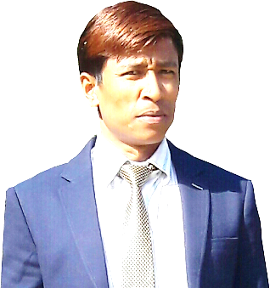
Mr. Deo
Position applying for Accountant/Asst. Accountant.
Email address : deo.382285@2freemail.com
Nationality : Bhutanese
Married status : Married
Visa status : Visit visa
Address : Abu Dhabi

OBJECTIVE
Newer concepts and career opportunities on the rise everyday give an ever-lasting opportunity to test one’s ability to adapt to these concepts and use it to strategize their personal growth. My experience has a proven track record of my ability not only to accept changes as they come but also to test my potential to its maximum and overcome shortcomings if any with the shortest learning curve possible and be most productive to the organization.

EDUCATION
Post Graduate in Financial Management (PGDFM) from the Royal Institute of Management,
Thimphu Bhutan. (June 2001)

WORK EXPERIENCE

- Asst. Accountant(Currently working from May 2018)
LeChocola, Abu Dhabi, Khalifa Br. UAE.
Responsible in
- Accounts (Accounting Entries, Banking, Tax Returns etc.)
- Inventory
- Cash Handling (cashier)
- Salesman

- Finance Manager (Jan: 2013-Sept: 2016)
Xcel Enterprise, Thimphu Bhutan.
Responsible in
1. Accounts (Book Keeping, Reporting, Banking, Tax Filing)
2. Budgeting
3. Procurement
4. Driving LV
5. Marketing

- Accountant (Dec: 2005-Dec: 2012)
Dzongkha Development Training Institute, Thimphu Bhutan.
Responsible in
1. Accounts (Books Keeping, Reporting, Banking, Tax Filing)
2. Budgeting
3. Procurement
4. Accounting Tutor (Taught Basic Accounting for monks)

- Cashier/Accountant (June: 2001- Dec:2005)
Bhutan Telecom Limited, Thimphu Bhutan.
Responsible in
- Sales of Mobile Handsets, SIM cards, vouchers.
- Customer Representative, bill collection, customer handling etc.

OTHER SKILLS
- User-friendly with E-POS, Peachtree, Tally ERP-9, GABS, TIIMS.
- Good skills in computer hardware and software
- Driving light, Medium, passenger taxi and two wheeler.
- Graphic Designs in Adobe Software's.
- Good communication skills for marketing and sales.
- Good Skills in Proposal Write-up in English.
- Good skills in making photo frames.
- Adequate knowledge in agriculture farming.
- Can Sing and play Music.
- Have adequate knowledge of Bhutan history which has its unique culture and traditions.
________________________________________________________________________________
LANGUAGES KNOWN
- English- read, write and speak
- Hindi- speak only
- Nepali- speak only
- Dzongkha- read, write and speak
- Sharchogpa-speak only

VOLUNTER Taught more than 1000 Bhutanese monks about Unicode to help them with accounting in Dratshangs.

ACHIEVEMENTS Recommendations for converting Black and white picture of His Majesty, the First King of Bhutan.

ADDITIONAL TRAININGS/COURSES
- Food and Beverages in Hotel Druk (2 months) 2001
- Telecom Integrated Information Management Systems 2003
- Dzongkha Computing 2011

- Refresher Driving Course for Commercial Vehicle Drivers 2013

DECLERATION

I hereby declare that the above furnished information is true and fair to the best of my knowledge and belief. I will be extremely happy to get an opportunity to join your organization and assure youwith the utmost sincerity towards my job at all times.

THANK YOU

