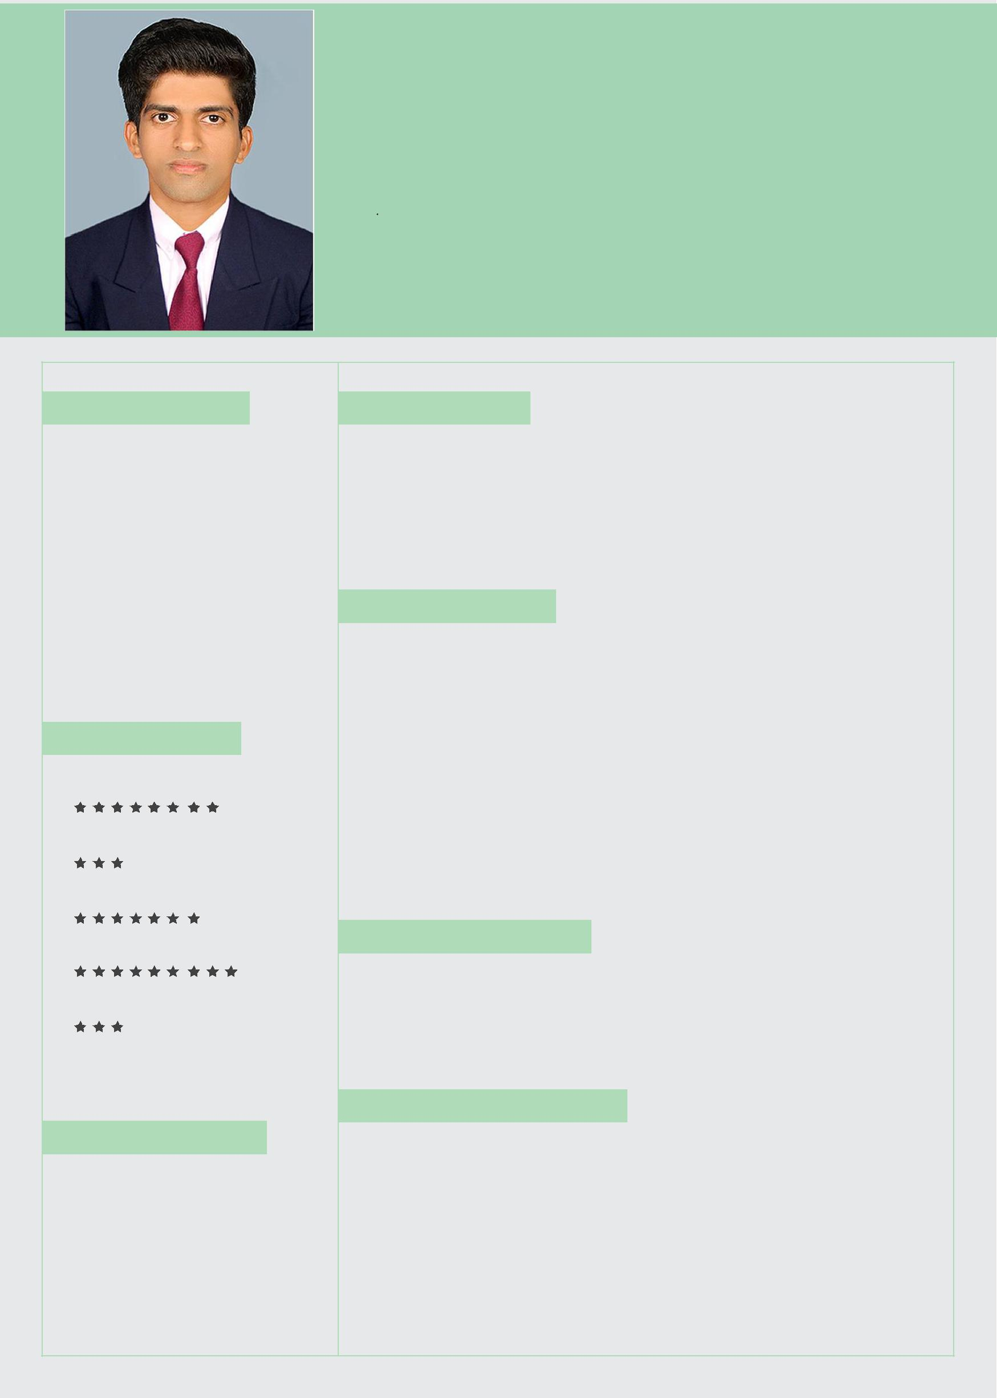
NIKHIL

LOGISTICS EXECUTIVE

Nikhil.382299@2freemail.com

EDUCATION

POST GRADUATE DEGREE

June 2015 - May 2017 Bharathiar University

MBA, Logistics & Supply Chain Management

UNDER GRADUATE

June 2012 - May 2015

Calicut University

Bachelor of Business

Administration

EXPERTISE

Microsoft Word

Microsoft Power point

Microsoft Excel

SAP

Tally

OBJECTIVE

Result-oriented, Logistics Management professional with expertise in 3PL solutions. Highly adaptable to different logistics environments; experience in FMCG. Proven ability to develop creative solutions to Warehouse Management.

EXPERIENCE

4 years of hardcore successful Logistics exposure with expertise in Warehouse management from April 2014 to April 2018.

WareHouse Supervisor @ KITE LOGISTICS (3PL) Distribution & Logistics, Reliance Retail Ltd

Warehouse – 40,000 Sqft ( Capacity 1300 Pallet location and 6500 Shelving )

Operations – Dry Warehouse (WM Warehouse)

Products – Staples, FMCG – Processed Food, Non Food, Dairy & Beverages

CERTIFICATION

On Job Training In SAP Certificate in Accounting Package MS Office

SKILLS & HOBBIES

- On Ground Sports

- Travelling the world

- Reading

- Swimming

- Listening to music

- Creative

- Adaptable

  - Communication Skills

    - Organized

    - MS Office

Areas Of Operation

Supervise Warehouse Inbound, Outbound and Inventory.

- Plan Inbound process as per schedules given to vendor

- Vendor follow-up for increasing the vendor fill rate

- Co-coordinating with category for problem freight consignments i.e. (MRP, EAN, PO Expiry, Short shelf life and case configuration mismatch against PO).

- Monitor work efficiency of workers on Plan outbound process as per schedules given for the day

- Monitor works efficiency of workers on each stage

- Ensure basic documentation and records

- Picking efficiency of workers

- Ensure 100% physical checks ready for shipments

- Reconciliation of location mismatch

- Planning and effective utilization of Secondary distribution vehicle and reverse logistics.

Responsibilities & Achievements

- Responsible for supervising all logistics operations for Reliance Retail in Kerala State.

- Responsible for all Customer accounting/documenting operations for Kerala.

- Receiving goods as per the Purchase Order basis.

- Locate, pick and pull, wrap & palletize inventory and materials

- Ensuring the Warehouse Stock and keeping statutory registers.

- Operated forklifts & pallet jacks for the stocking, loading and unloading and on-site transportation

- Responsible for maintaining “ Good operating practices” / SOP

- Supervising a team of 30 workers personnel for all Warehouse operations

- Significant Role in driving Ware house Efficiencies in terms of Service time and ensuring Standard hygiene practices critical for Food Warehouse.

- Maintaining FIFO and periodic disposal of waste/rejected materials.

- Have Attended Reliance Retail training programs in Warehouse/ Distribution Quality management program.

- Significant Exposure to SAP based Logistics Operations. Conversant with MS-Office applications.

- Team Leader for audit conducted in our warehouse.

Personal Profile

Nationality
Gender
Date Of Birth

Languages Known
Visa Status

: Indian
: Male
: 1st December 1994
: English, Hindi, Malayalam
: Visit

Declaration

I hereby declare that the information furnished above are true to the best of my knowledge and belief. I assure judicious performance of my duties with a commitment to Excellence.

