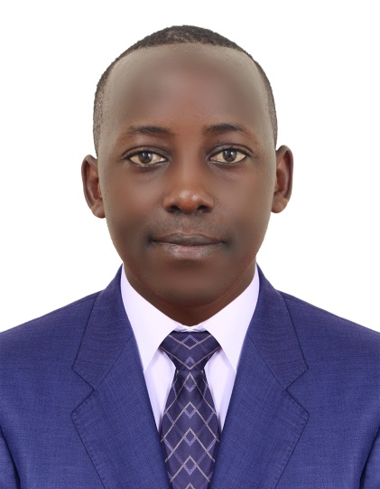
CURRICULUM VITAE
CHEF
PERSONAL INFORMATION
NAME: DENNIS
EMAIL dennis.382303@2freemail.com
NATIONALITY: Kenyan
MARITAL STATUS: SINGLE
VISA STATUS: Visit Visa
LANGUAGE: English
LOCATION: DUBAI.
Career Profile
A dynamic smart and interactive young man with a sound professional background seeking for placement in any collaborative and challenging environment where integrity and corporate governance are highly valued with the objective to improve my career and support the organization to achieve its goal.
This is my strong personal attributes:
- Able to work under pressure
- Decision making ability
- Problem solving ability
- Confident
- Multi-tasking
- Excellent communication skills
- Team player
- Handle multiple tasks.
- Honest and considerate
Education
CERTIFICATE | NOV-2014 | KIAMBU INSTITUTE OF SCIENCE &amp; TECHNOLOGY
· Major: Food and Beverage
· Minor: Entrepreneurship
CERTIFICATE | NOV-2012 | KIAMBU INSTITUTE OF SCIENCE &amp; TECHNOLOGY
· Major: Baking Technology
· Minor: ICT
RESPONSIBILITIES:

Experience

sous chef | ruiru sports club | 2016 to- jUNE 2018
- Stores management
- Deputizing the Head Chef
- Planning and layout of Buffet
- A’ la carte

Internship - chef | thika sports club | june – august 2014
- Practical experience in meals planning, preparation and presentation

Internship - chef | nairobi serena | february 2012
- In-course industrial attachment to cover meals planning, preparation and presentation

HOBBIES.
Enjoy body building and playing football.
Referees are available upon request.

