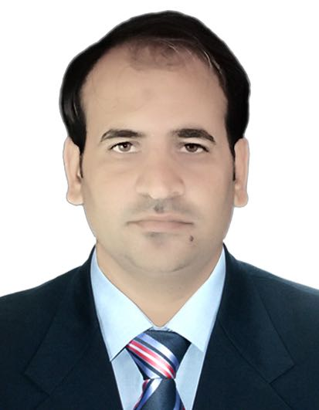
ADNAN

Email ID: Adnan.382309@2freemail.com

Visa Status: Visit Visa

Career Objective
To obtain a challenging position in an Organization that provides me the opportunity to enhance my skills and knowledge, and to utilize them efficiently for the organizational growth.
Profile Summary
- An enthusiastic professional with highly motivated skills having Bachelor of Arts degree in International Business and Finance from University of Derby, UK.
- Have a quality of adopting new concepts of studies as well as responsibilities.
- Able to achieve immediate and long term goals.
- Can create and maintain a comfortable work environment.
- Ability to deal with people diplomatically.
Personal Traits
- Highly motivated and eager to learn new things
- Good communication skills in written and verbal both
- Ability to work as individual as well as in group
Academia
- Bachelor of Arts (Hons) in International Business and Finance from University of Derby United Kingdomcompleting in Jun 2016.

Key Technical Skills
- Windows 7/8/10
- MS Office (Word/Excel/PowerPoint/Access/OneNote)
- Internet Savvy

Academic Project
Project Name:BusinessStrategies and Financial statement analysis of Volkswagen Group
Duration: 3 months
Description: In this project I had involved in studying and exploring the business strategies of Volkswagen in terms of internal and external factors, economic and environmental leadership, and the goals that are intended to make the company more thriving, enthralling and upholding automaker in the world.

Summary of the study:
- How the polices are designed to deploy intelligent innovations to see high customer satisfaction in order to achieve company’s long term success
- How the company set to a goal of unit sales of more than 10 million vehicles a year, so as to capture an effective share of growth in the automobile market
- Long term plans designed to ensure the solid financial position in difficult market periods
- Designated highly qualified team in the sector and motivated them to build best vehicles, and accordingly aimed to be the most attractive employer in the automobile industry
Work Experience

Company name: Meezan Bank Ltd Pakistan
Designation: Business Development Officer
Duration : Sep 2017 to May 2018
Roles &Responsibilities
  - Responsibility to achieve branch target in corporate current accounts.
  - Responsibility to increase the Bank's profitability by cultivating new business relationships.
  - Goal is to Grow accounts profitability by maintaining a high service standard and compliance.
  - Generate the cross selling business from existing customers by selling other products.
  - Maintain and develop customer relationships, new business, and periodic visit to existing customers.
  - Manage and track the leads and maintain DSR on regular basis.

Company Name Convert Services Ltd, London
Designation Admin cum Accounts Assistant
Duration April 2015 to Feburary2017
Description
Being SIA approved company specializing in the area of security guarding and door supervision, our company provides exclusive security services to businesses and organizations from all divisions of commerce and industry.
Roles & Responsibilities
  - Dealing with telephone and email enquiries
  - Creating and maintaining filing systems
  - Scheduling and attending meetings, creating agendas and taking minutes, keeping diaries and arranging appointments
  - Liaising with staff, managing payroll processing, organizing travel and accommodation for staff or customers and other external contacts
  - Assisting in preparing statutory accounts
  - Calculating and checking to make sure payments, amounts and records are correct
  - Reconciling finance accounts and direct debits and monitoring accounts mailbox
  - Post and allocate bank payment and receipts
  - Assisting the accounts team with day to day adhoc duties
  - Assistance with month end duties as required to meet Group Finance deadlines
  - Recruiting, training and supervising junior staff and delegating work as required
  - Arranging in-house and external events

Company Name : Nishat Textiles, Pakistan
Designation : Supervisor / Asst. Supervisor / Lab Technician
Duration : September 2008 to August 2010
Roles
- As a Lab technician involved in chemical testing, physical testing, colour dipping testing and forwarding samples
- When promoted to the Supervisor position, looked after people management, checking the quality of testing and reporting to the management
- Analyzes and improves manufacturing methods using sound data driven practices.
- Utilizes knowledge of textile products, materials, production equipment
- Capabilities, assembly methods, and quality control standards to drive change.

Strengths
- Hard working and quick learner
- Flexibility and adaptability to work in any environment
- Willingness to accept any challenge irrespective of its complexity
- Good team player and positive attitude

Hobbies
- Travelling
- Reading Books
- Interacting with people and learning new things

Personal details

Languages Known : English (Proficient), Urdu (Native) and Punjabi.
Driving License : United Kingdom full License Hold

