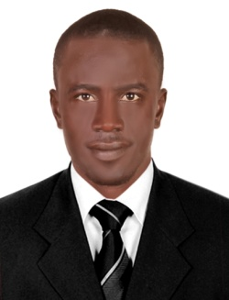
CURRICULUMVITAE

LAMIN

Lamin.3823478@2freemail.com

CAREER OBJECTIVE:

Individual seeking a positioning in dynamic and challenging environment in which new ideas of professional services are uncompromising. And I desire to work with a team utilizing exceptional skills to maximize the satisfaction of passengers and increase repute of employer.

SUMMARY OF SKILLS:
*Exceptional communication skill and hospitality.
*Hard-working and Dependable.
*Good listening skill.
*Friendly and Polite in all Situations.
*Positive attitude at all times with basic understanding of English language.
*Ability to persuade others.

EMPLOYMENT HISTORY:

Coco ocean hotel and spa, HOUSEKEEPING/ROOM ATTEDANT the Gambia, Banjul

January 2014 - Dec 2018.
- Highly skilled in cleaning guest rooms per established standards.
- Ability to work calmly and effective under pressure.
- Familiar with the operation of various cleaning equipment.
- Excellent communication and interpersonal skills.
- Able to maintain a professional appearance and behavior at all times.
- Ability to work proactively within a team and on own initiative.
- Able to handle individual requests in a way that ensures guest contentment.
- Competent at ensuring each guest room meets established level of sanitation.

EDUCATIONAL BACKGROUND:

2007 - 2010GambiaHighSchool, Gambia West African high school diploma
2002– 2005 Gunjur upper Basic school GABECE CERTIFICATE

PERSONAL INFORMATION:
Birth date: 25/02/1986
Gender: male
Status: Single
Nationality: Gambian
Visa Status: Visit Visa

PERSONAL SKILL
Goodcommunicationabilityandstronginter-personalrelationshipHighsenseofcommitment, diligence and strong motivating, ability, Anticipation and satisfaction.
Ability to work under pressure and discharge analytical ability

References available upon request

