Curriculum vitae

Personal Information
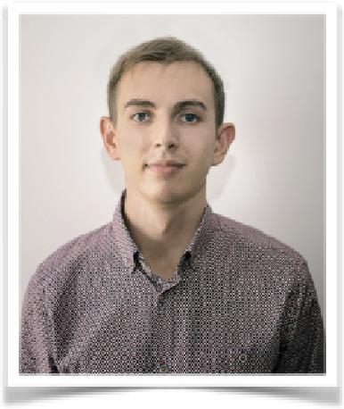

FIRST NAME / SURNAME | Dmyrto
ADDRESS | UAE, Dubai
EMAIL | Dmyrto.382361@2freemail.com
NATIONALITY | Ukrainian
DATE OF BIRTH | 07.03.1992 (26 y.o.)
GENDER | Male
DESIRED POSITION | Sales Associate, Customer Service
Work Experience

DATES

POSITION

RESPONSIBILITIES

EMPLOYER / ADDRESS

DATES

POSITION

RESPONSIBILITIES

EMPLOYER / ADDRESS

November 2017 - present

Senior Waiter

Provide guests with an exceptional dining experience and monitor dining area to ensure best quality service Handle all routine customer problems, ensuring all concerns were corrected and customers left satisfied Train new waitstaff on basic techniques and the specific

expectations and procedures in the restaurant Ramusake Japanese Restaurant / UAE, Dubai

November 2016 - November 2017 Commis De Rang

Provide professional and efficient service

Be knowledgeable of all services and products offered by the hotel

Ensure that the work place is kept clean and organized Handle guest enquiries; report guest complaints Attend all staff meetings, and hotel initiated trainings scheduled
Palazzo Versace | Enigma Restaurant | UAE, Dubai

Curriculum vitae

DATES | January 2015 - April 2016
POSITION | Waiter
RESPONSIBILITIES | Serving guests as per high luxury standards
 | Promoting Starwood Preferred Guest program
 | Maintain smooth operation on the floor
 | Project at all times a positive and motivated attitude and
 | exercise self-control
EMPLOYER / ADDRESS | St. Regis Doha | Qatar, Doha
DATES | March 2015 - November 2015
POSITION | Sales Associate
RESPONSIBILITIES | Welcome customers, give advice and guidance on
 | product selection to customers
 | Follow policies and procedures relating to cash credit
 | card transactions, stock handling and pricing
 | Handle customer’s complaints in a professional way
 | Organize promotional events and set up displays
EMPLOYER / ADDRESS | Mobile store "Allo" | Ukraine, Kiev
Education and Training | 2009 - 2012
DATES
QUALIFICATION AWARDED | Bachelor
PRINCIPAL STUDIES | Tourism service, hotel business and gastronomy
INSTITUTION | University of Information Technology and Management
 | Poland, Rzeszow
ADDITIONAL | Starwood Service Culture Training |Food Hygiene
 | Training | CrossTraining Certificate for Bellman
Skills and Competences | Polish language Diploma
LANGUAGE SPOKEN | English | Russian
OTHER LANGUAGE(S) | Ukrainian | Polish
COMPUTER SKILLS AND | Advanced in POS Micros | Excellent skills in Adobe
COMPETENCES | Photoshop | Regular user of Microsoft Word, Power point
 | and Microsoft Excel

