RESUME

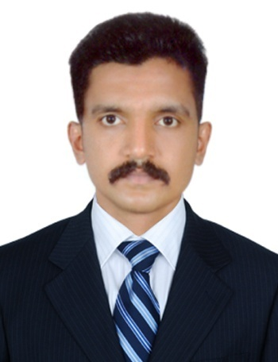

ARUN

Email ID: arun.382386@2freemail.com

CAREER OBJECTIVE
To obtain professional and technical excellence through sincerity and hard work in professional and caring organization that provides a promising career progression.

PROFESSIONAL EXPERIENCE

Oct 2016 – April 2018 | George& Company. Thrissur, Kerala, India
Position | Hr Assistant
DUTIES & RESPONSIBILITIES :
- Substantiates applicant’s skills by administering and scoring tests.
- Schedules examinations by coordinating appointments.
- Welcomes new employees to the organization by conducting orientation.
- Provides payroll information by collecting time and attendance records.
- Submits employee data reports by assembling, preparing, and analyzing data.
- Maintains employee information by entering and updating employment and status change –data.
- Provides secretarial support by entering, formatting, and printing information; organizing work; answering the telephone; relaying messages; maintaining equipments and supplies.
- Maintains employee confidence and protects operations by keeping human resource information confidential.
- Maintains quality service by following organization standards.
- Maintains technical knowledge by attending educational workshops; reviewing publications.
- Contributes to team effort by accomplishing related results as needed.
- Supports human resources processes by administering tests; scheduling appointments; conducting orientation; maintaining records and information.

CAREER HIGHLIGHTS
- Above 1 year & 6 months, experience in Hr
- Work experience in Hr assistant
- Team-work I can complete all my work within given time
- Leadership Quality
- Co-operative mind
- Good team player and team leader

Educational Qualification
Course | Subject | Duration | Course | Country
MBA | Hr&Marketing | 2Years | Post Graduation | India
BE | Civil | 4Years | Graduation | India
HIGHER SECONDARY | SCIENCE | 2Years | Plus Two | India
SSLC | State board- | - | KSB | India

Personal Information
Name : Arun Date of Birth : 17/07/1992
Nationality : Indian Marital Status : Single
Sex : Male

I, Arun certify that the above mentioned details are true.

