\\  CURRICULUM VITAE  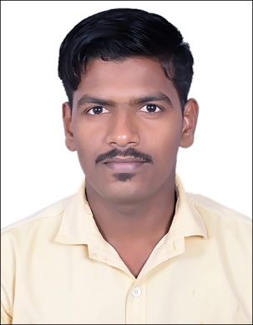  CONTACT INFORMATION  DIPIN  CURRENT STATUS:  EMPLOYEMENT  Expiry: Oct 2018  E- mail:-  Dipin.382434@2freemail.com  PERSONAL DETAILS:-  DATE OF BIRTH: 02/05/1995  SEX: MALE  NATIONALITY: INDIAN  MARITAL STATUS: SINGLE | LOGISTIC OFFICER /STORE KEEPER  Career Objective:  "Seeking for a suitable position in an esteemed organization to provide my learning attitude and updating knowledge on constructive abilities and desirous to make my career enable my quality of work as deemed to achieve the desired, challenging career professionalism."  Professional  - STORE ASSISTANT IN WESTERN INTERNATIONAL GROUP,UAE  (Sep 2016 – Present)  - BRANCH REALATIONSHIP OFFICER IN MUTHOOT FINCORP, KERALA, INDIA ( July 2015 – March 2016)  computer Abilities  - Diploma in Computer Application(DCA)(FastTrack)  - knowledge in SAP ERP, Tally  - Maintaining Excel Spreadsheets And Microsoft Word  Academic Qualification  - Bachelor of commerce, 2016  - Higher Secondary School Examination, 2012  - Secondary School Leaving Certificate, 2010  Area of Interest and other skills :  - Ability to envision creative ideas and programmes, then follow thoroughly on the details to ensure successful implementation.  - Consensus builder and skilled negotiator with the ability to build and maintain excellent relationships.  - Able to make rapid assessments and quickly revise tactics to ensure progress and good achievement.  - Ability to perform well on both independent contributor and team member.  - Mailing  - Leadership skill
STRENGTHS:  - Ready to take up international assignments  - Good communication skill and convincing capability  - Team working and effective in leading  - High zone of tolerance and hardworking  - Observant and adaptable for new technology and changes  - Well versed with internet research method.  .  HOBBIES:  - MUSIC  - DRIVING | Language known :  Language Speak Write Read  Malayalam √ √ √  Tamil √  Hindi √ √ √  English √ √ √  Reference:  Can be furnished upon request.

