AREAS OF EXPERTISE

Guest satisfaction Serving meals Laying tables
Hygiene
Up-selling food and drinks Hospitality

Jonnathan
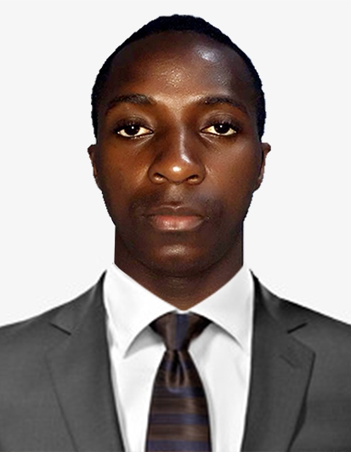

Waiter

PERSONAL SUMMARY

A hospitable, presentable and hardworking team player who possesses a high standard of personal appearance and hygiene. Always focused on making sure that every guest is served to the highest possible standards by having an outgoing, polite and professional attitude towards all patrons. Constantly working hard to ensure that guest expectations are met and that their time being served is a memorable experience. Jonnathan naturally enjoys talking to people and is much experienced in overseeing the smooth running of a busy dining area, and in creating a unique relaxed style and atmosphere. He is now ready for new challenges and is now seeking a suitable position with a reputable and exciting company.

WORK EXPERIENCE

Emirates Palace – Abu Dhabi
WAITER April 2016 – up to date

Duties:
- Greets and escort customers to their tables
- Cheek customers IDS to ensure they meet minimum age requirements for a cccconsumption o
- Consumption of alcoholic beverages
- Serve food and drink orders
- Check dishes and kitchenware for cleanliness and presentation and report ant problems
- Arrange table settings and maintain a tidy dining area

- Delivers checks and collect bill payments

Carry dirty plates, glasses and silverware to kitchen for cleaning

- Tamara Restaurant - Kampala
- WAITER
- 2014 – 2015

PERSONAL SKILLS

Desire to succeed Winning work ethic

CompetitivemindsetCommunicating Attention to detail
- Ability to recommend Food & Beverage combinations and up-sell alternatives.
- Explaining how food is prepared, describing ingredients and cooking methods.
- Experience in a previous front of house role.
- Excellent command of the English language.
- Able and willing to work varying shifts.
- Building a rapport and relationship with customers.
- Experience of working in a luxury environment.
- Ensuring that customers enjoy their meals and taking action to correct any problems.

KEY SKILLS AND COMPETENCIES

PERSONAL DETAILS

Gender: Male
Nationality: Ugandan
DOB: 01/11/1992
Visa Status: Employment Visa
Email: jonnathan.382454@2freemail.com

ACADEMIC QUALIFICATIONS

Uganda Advanced Certificate of Education (U.A.C.E) 2013

A level: St Johns High Sec. Sch

Uganda Certificate of Education (U.C.E) 2011
O levels: Mackay Memorial sch

REFERENCES- available upon request

