CURRICULUM VITAE

PERSONAL DATA

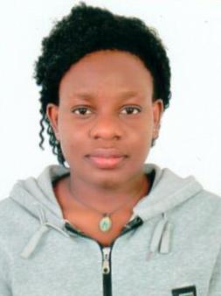
NAME: CHRISTINE
DATE OF BIRTH: 22/12/1996

NATIONALITY: UGANDAN
EMAIL: Christine.382463@2freemail.com

OBJECTIVE

To improve my skills and knowledge as a waiter; become part of a reputable fine-dining restaurant in U.A.E; and run my own restaurant in the future.

SUMMARY OF QUALIFICATIONS

- 2 years’ experience in the busy and fast-paced restaurant settings.
- Ability to work effectively under time pressure
- Dedication to work
- Ability to understand different kinds of people
- A friendly, cheerful, and polite attitude

ACCOMPLISHMENTS

- Reorganized restaurant merchandise storage place.
- Designed and implemented a new strategy for meals that increased customer satisfaction.
- Helped in reorganizing the restaurant on daily basis.
- Good handling of the customers and team work.

PROFESSIONAL EXPERIENCE

Waitress | 2K RESTAURANT (2016 – 2017)

Responsibilities
- Presented the menu to customers, answered queries and made suggestions if necessary
- Attended to customers’ needs
- Maintained cleanliness in the counters, some parts of the kitchen, and tables
- Did other tasks assigned by supervisor
- Prepare foods for cooking
- Greeted customers and welcomed them with a smile

Waitress | TICK HOTEL (2017 – 2018)

Responsibilities
- Informed patrons the restaurant’s daily specials
- Served food and beverages promptly
- Check on customers to ensure they are enjoying their meal
- Stock service areas with supplies such as coffee

EDUCATIONAL BACKGROUND

- 2015 – 2017 Diploma in journalism and mass communication
- 2013 – 2014 Kyadondo secondary school
- 2009 – 2012 oxford high school.

CERTIFICATIONS

- Diploma in journalism and mass communication 2017
- Uganda Advanced Certificate of Education 2014.
- Uganda Certificate of Education 2012
- Computer Training

LANGUAGES

- English

ADDITIONAL SKILLS

- Superb communication skills.
- Able to follow orders efficiently.
- Good attention to detail.

