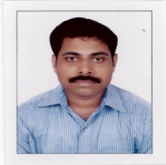
SHYJU

E-Mail: shyju.382488@2freemail.com

Application for any suitable post in Inspection / QA/QC/Welding/Painting/Fabrication
Visa status: On Visit Visa

PROFILE SUMMARY

Nearly 16+ years of experience in fabrication-heavy structures, vessels, piping (11 years in UAE & 5 years India)
in:

Quality Assurance/ Control Welding/PaintingTesting Inspection & Validation
Qualifications: DME / CSWIP 3.1/ NACE Level 1/ QMS LA -ISO 9001:2008/ ASNT NDT Level II (RT,UT,MT,PT)/CSWIP3.2.2 appeared

Availability :Ready to join immediately.
UAE Driving Licence: Yes (LMV-Automatic)

- Associated with Automech Heavy Industries/Alucor Ltd, Jebelali Free Zone, UAE as Quality Engineer-November 2006 To 14th February 2018.
- Demonstrated abilities inintroducing quality assurance practices to achieve business excellence at the lowest overall cost with focus industry and technology trends
- Functional expertise in implementing project plans and monitoring progress as per scheduled deadlines for various tasks and taking necessary steps to ensure completion within time, cost & effort parameters with a team of Engineers, Supervisors, Inspectors and minimal workforce
- Proven track record of significant improvements in productivity, quality and efficiency improvement while reducing costs, lowering turnover & maintaining a positive work environment
- Sound knowledge and solid understanding of various codes and specifications encompassing ASME Sec VIII Div 1, ASME SEC II A, IIC, ASME Sec IX, ASME SEC V, ASME B31.1, AWS D1.1, AWS D1.2, EN 25817, EN 287-1, EN 15614-1 etc.
- Excellent relationship management, analytical & negotiation skills; deftness in swiftly ramping up projects in coordination with Architects, Consultants & Contractors
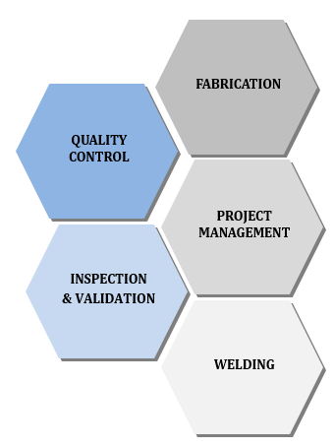
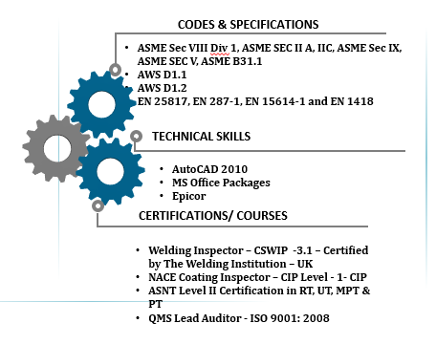
ORGANIZATIONAL EXPERIENCE

Nov’06- Feb’18 Automech Heavy Industries/Alucor Ltd, Jebelali Free Zone, UAE as Quality
Engineer

May’06 – Oct’06 Domech Engineers Pvt. Ltd., Mumbai as Shop Floor Supervisor

Aug’04 – Apr’06 Reshmi Fabricators Pvt. Ltd., Mumbai as Junior Engineer

Sep’01 – May’04 Thejo Engineering Services Ltd., Chennai as Technical Assistant

Key Result Areas:

Quality Assurance / Control
- Monitoring adherence to quality systems and maintaining requisite documents
- Handling the preparation of quality control procedures, ITP’s, method statements etc.
- Creating effective procedures for the preparation & implementation of programs within all areas of safety, health and the environment

Project Management
- Overseeing project activities from conceptualization to execution including business definition, feasibility & optimization, project planning, implementation, site management and manpower planning
- Executing the process of project tracking and communicating with client, internal business partners, top management and with project core team
Welding Operations
- Preparation of PWPS’s, conduct PQR’s& WQT, witness mechanical tests, prepare WPS’s etc.
- Selecting the proper welding process that gives the highest quality welds & ensuring parameters according to WPS
- Reviewing welding job and providing information on material and weld traceability and NDT as well as complete welding supervision and inspection
Testing
- Monitoring work in progress for compliance with the latest approved revisions of drawings and specifications and verifying that finished work meets acceptance criteria
- Preparing and documenting WPS, PQR & WQT as per job requirements while supervising WPQR & WQT with 3rd Party Vendors like LLOYDS, BV, TUV, ABS, etc.
- Planning procedures for hydro test, leak test, etc. while ensuringtransfer of relevant information to production, planning and safety departments for proper testing arrangements
Inspection
- Executing inspection of Material receiving, fit up, welding, dimensional, hydro test and other inspections according to approved ITP
- Executing inspection of galvanizing and painting at subcontractors yard as per QAP/ ITP
- Approving the material if it meets the specification/standard and rejecting the material if it does not meet specification & inspecting & testing of materials

Highlights:
- Recognized as the main participant to prepare Quality Manual & Exhibits and gaining ASME U, PP & R Stamp authorization for Automech Heavy Industries

Major Projects:
At Automech Heavy Industries/Alucor Ltd
- Instrumental in executing fabrication of the following:
- Fabrication of Pony sub and other items – TESCO
- Fabrication of DSS pipe spools- Basrah Water Supply Improvement Project – SIDEM/OTV
- Fabrication of 16MC water tanks – Saipem Portugal
- Fabrication of structural steel work- Shindaga Shopping Mall-PQD Contracting
- Fabrication of different types of crushing and grinding chutes ( SS & CS) –BPJV- EMAL Phase II
- Fabrication of aluminum handrails - EA ONE OFF SHORE WIND FARM- LAMPRELL
- Fabrication of pipe supports- MGT system for GC’s 29,30 &31-KOC Kuwait – Petrofac
- Fabrication of jacketed pipe lines – BPJV- EMAL Phase II
- Fabrication of conveying Pipes - FLSMITH - EMAL Phase II
- Fabrication of structures for Rumaila Inlet booster compressor project - Worley parsons
- Fabrication of Air slides - Alstom- EMAL-Phase II
- Fabrication of Cyclone and Cyclone Inlet Piping - ECL Middle East
- Fabrication of jacketed pipes-Enersul- KNPC MAA Refinery
- Fabrication of Structures, process water skid ,tanks and pipings, Aluminum packages- Enersul- KNPC MAA Refinery
- Fabrication of primary, Secondary and civil supports - Petrofac- Alrar Inlet Separation facilities- Algeria
- Storage Silo, KO Drum, PG Venturi, PG Orifice - Emirates Steel Industries
- Storage Silos, Structures, Jacketed Pipes, Aluminum Supply (Reliance Jamnagar - J3 Program)-ENERSUL
- Granulation Drums, Skids, Piping & Tanks (KharyagaProject) – ENERSUL
- Granulation Drums, Skids, Piping & Tanks (AntipinskyProject) – ENERSUL
- Granulation Drums, Skids, Piping & Tanks (Badra Project) – ENERSUL
- Granulation Drums and Skids (Reliance Jamnagar J3 Program) – ENERSUL
- Structures, Towers, Tanks&Jacketed Pipes (HabshanProject) – ENERSUL
- Structures, Towers, Tanks &Jacketed Pipes (Shah Project) – ENERSUL
- Structures, Silos, Conveying Pipes, Pipe Supports, etc. – EMAL Phase II
- Conveyor Structures & Tilter (Sphnix –Saudi) – Outotec
- Casting Benches & Reject Conveyors (Dubal) – Outotec
- Flow Sleeves – GE Energy
- Pedestrian Bridge, lift Frames (R 98-Near Trade Center) – WaagnerbiroGulf
- Camel Race Track Foot Bridge, Lift Frames (R 90-Alain) – Waagnerbiro gulf
- Fire Escape Stair Cases, Lanterns and Awnings (Al Zeina)- Aldar Laing O Rourke
- Cranes (Dubal) – NKM Noell
- Anode Rotator Frames (EMAL-Phase II) – Outotec
- Casting Bench Assembly (Dubal) – Outotec
- Ducts, Chutes & Pipes - Descon Engineering Limited
- Spud Can Parts - Q G M Group
- Transition Elements-Floating Bridge –Bur Dubai- Waagner Biro
- Dampers (Sohar Aluminum Smelter), Petron, Dubai
- Dome Roof Structure of Tanks (Qatar Airport)-Punj Lloyd, Qatar
- Truncated Columns (Al Zeina)- Aldar Laing O Rourke
- Piles - Musandam Rocks
- Main Crane Pedastal - Dubai Ship Building
- Air Receiver Tank - Demo Vessel- ASME
- Sprinkler Tank - Al MasaoodBergum
- Pedestrian Bridges & Structures - Metro Project - Waagner Biro
- Roof Structure - Fish Market –EDSE
- B20 Deoiling hydro cyclone test vessel - MISWACO
- Fabrication of structures -Ebla Gas project -JI190 -Petrofac
- Fabrication of structures - South Yolten Gas fileld development- Turkmen gas - JI 199 -Petrofac
- PQR & Welders Qualification in Different Position & Process- Internal Requirements

ACADEMIC DETAILS

- Diploma in Mechanical Engineering from Technical Board of Examinations, Kerala in 2001
- Pre Degree from Mahatma Gandhi University, Kerala in 1998

PROFESSIONAL ENHANCEMENTS

Certifications:
- Welding Inspector – CSWIP -3.1 – Certified by The Welding Institution – UK ; Certificate Number- 49069/2; Expires on – Aug’2020
- Welding Inspector – CSWIP -3.2.2 – Seminar attended.
- NACE Coating Inspector – CIP Level - 1- CIP; Certification Number – 48690; Expires on – Nov’19
- ASNT Level II Certification in RT, UT, MPT & PT
- QMS Lead Auditor - ISO 9001: 2008 Course Number A17070 by IRCA; Certificate Number ENR-00117100

TECHNICAL SKILLS

- Well versed with:
  - AutoCAD
  - MS Office Suite (Word, Excel and PowerPoint)

PERSONAL DOSSIER

Date of Birth : 20thJuly, 1980
Languages Known : English, Hindi and Malayalam
Nationality : Indian
Marital Status : Married
No. of Dependents : 2
Driving Licence : Valid UAE Driving License –Automatic Light Vehicles

