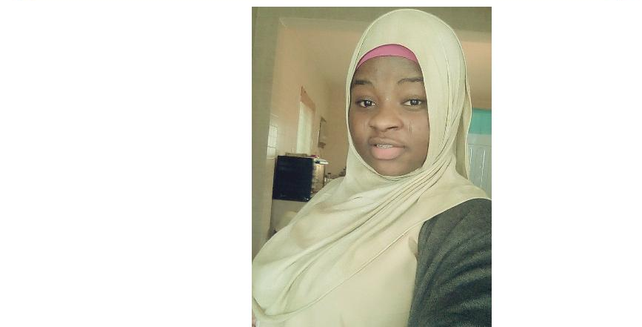

​PERSONAL INFORMATION
Name : Aminat
Email : aminat.382490@2freemail.com
Date of Birth : May 3rd,1993
Gender : Female
Marital Status : Single
Nationality : Nigerian
Language known : English
Visa Status : Visit Visa

CAREER OBJECTIVES

An energetic and enthusiastic food service professional with proven experience in a fast-paced hospitality environment. Skills and strengths include:

WORKING EXPERIENCES

Eko Hotel​,Lagos, Nigeria
Job Position: Waiter

Job Description

Jan 2016 – Jul 2017

- responsible for serving X customers on average per shift

- welcome and seat guests

- present and discuss menus

- answer questions and provide suggestions on food and beverage options

- take orders and enter into a POS system

- serve food and beverages including speciality dishes

- deal promptly with requests and complaints

- perform running side work throughout shift

- prepare final bill and process payments

- clean and set tables

D’Rovans Hotel,

Lagos, Nigeria
Position: waiter

Job Description

June 2014 – Dec 2015

  - Escorts customers to their tables and ensures they are settled comfortably; offers coffee and other drinks

  - Presents the menu to customers, answers queries about it, and makes suggestions if necessary
  - Explains the preparation and cooking methods as well as ingredients of various menu items
  - Takes orders from customers for food and beverages, writes down or memorize the orders; and enters information into the computer for transmittal to the kitchen
  - Serves food and beverages promptly
  - Ensures that customers are enjoying their meals or that they do not have any problem with their food
  - Collects the customers’ payments and prepares bills with itemized costs and appropriate taxes
  - Prepares and tidies up the tables or counters; makes sure there are enough salt, sugar, pepper, cream, other condiments and napkins in every table or counter.
  - Decorates dishes prior to serving
  - Stays alert for customer’s requests and be prompt to address them
  - Performs other tasks assigned by supervisor or manager from time to time.

- AND I ALSO HAVE​​ GOT ONE YEAR EXPERIENCE IN HOUSEKEEPING IN OMAN JULY 2017-MAY 2018,​SO I CAN ALSO WORK AS A ​CLEANER​TOO​.

EDUCATIONAL QUALIFICATION

- Completed Secondary School Certificate (O Level)

SKILLS AND COMPETENCIES

- customer service orientation

- organization and planning skills

- accuracy and attention to detail

- persuasive skills

- team member

- stress tolerance

REFERENCE

Available upon request

