GRACIOUS
ABOUT ME
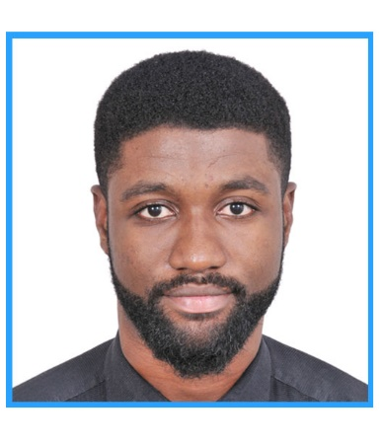
I'm Gracious, born on September 07, 1991 in Ho, Ghana West/Africa. Been living and freelancing in India for the past 5years.
I'm a passionate Web Designer & Developer with the goal of employing the very best of my knowledge in every project I undertake and my enthusiasm is boundless.
I design in the browser with HTML(5), CSS(3) and a touch of JavaScript. I love coding things from scratch, but I can work with front-end frameworks like Bootstrap and WordPress too. Looking forward to work in a purpose driven environment to achieve exciting results.
SKILLS
PROGRAMMING LANGUAGE: - HTML5, CSS3, JAVASCRIPT.
WEB FRAMEWORK: - BOOTSTRAP 4, WORDPRESS.
ADOBE CC/CREATIVE CLOUD: - PHOTOSHOP, EDGE ANIMATE, MUSE.
EXPERIENCE
FREELANCING 2014 - PRESENT Designed and Developed Website for corporates such as Acuere Consultancy India,
Cleftrock India, Marken Graphics Ghana, Wallahs Academy Ghana, DreamsAfrica Ghana etc....
EDUCATION
CERTIFICATION IN ANDROID PROGRAMING
-NIIT BANGALORE, INDIA.
DIPLOMA IN ADVANCE JAVA
-ARENA BANGALORE, INDIA
BACHELORS IN COMPUTER APLLICATION
-BANGALORE UNIVERSITY, BANGALORE, INDIA.
SENIOR HIGH SCHOOL CERTIFICATE
-MAWULI SENIOR HIGH SCHOOL, HO, GHANA.
CONTACT US
EMAIL: gracious.382526@2freemail.com

