CURRICULUM VITAE

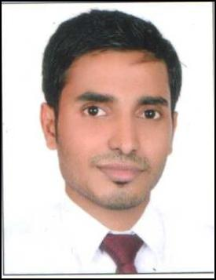

DHANESH

Email: dhanesh.382527@2freemail.com

Dubai, United Arab Emirates.

OBJECTIVE

To seek a challenging career opportunity atmosphere to learn, grow and apply advancement and organizational tasks.

in administration that would offer good my skills for achievement of personal

PROFESSIONAL EXPERIENCE

- Worked as Waiter in Al Rousha Restaurant, Abu Dhabi UAE for 3 years .

Duties & Responsibility
- Explain various dishes on the menu to patrons and make recommendations.

- Take orders and relayed the same to kitchen staff

- Ensure simultaneous preparation of all orders for a single table and serve in professional manner

- Calculate meal costs and add taxes for final bill calculation

- Greeted guests, took orders and served the same

- Cleared tables and set them before and after the guests left

- Assisted in kitchen when needed

- Worked as Cashier in Al Rousha Restaurant, Abu Dhabi UAE for 4 years .

Duties & Responsibility
- Calculate discounts and rewards as appropriate.

- Tag items for price and expiry date.

- Operate cash register and adding machine to receive cash for sold items

- Balance all transaction at the end of the day for cash reconciliation

EDUCATION
- 12th Class ( Intermediate )

- Computer Skills : Basic Computer Knowledge & Internet

SKILLS
- Hardworking and determined

- Fast learner with multi tasking capabilities

- communication skills

- Ability to work under pressure in fast paced environment & Mange Multiple tasks .

PERSONAL INFORMATION
❖ Date of Birth | : | 28-03-1987
❖ Nationality | : | Indian
❖ Marital Status | : | Married
❖ Languages | : | English, Arabic , Hindi & Malayalam
❖ Visa Status | : | Visit Visa

DECLARATION

I hereby declare that the above given information is true to best of my knowledge.

