CURRICULUMVITAE
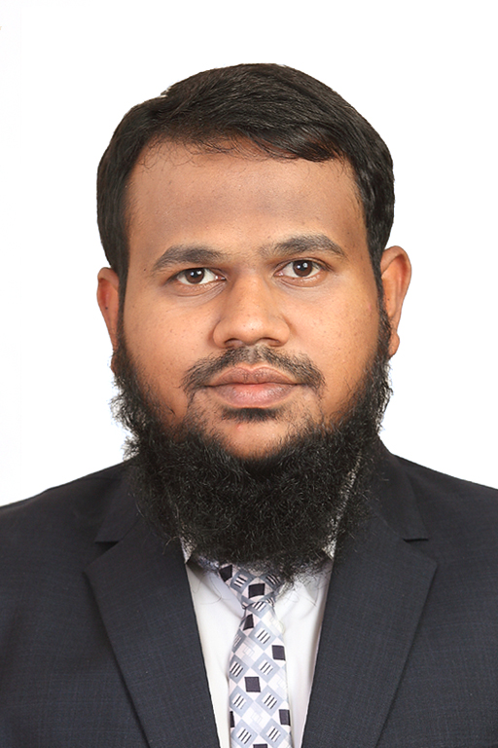
PERSONAL INFORMATION:
Name: Mohammed
Profession: Physiotherapist
Nationality: Indian
Current Location: Dubai, UAE
Visit Status: On Visit
Email: mohammed.382552@2freemail.com

OBJECTIVE: To work with a center of therapy that gives me a chance to improve my knowledge and skills as a Physiotherapist and climb up the ladder of success along with taking my organization to heights of popularity and respect.

WORK EXPERIENCE: 2.5 years of professional experience
- Worked as Physiotherapist at Healthwin Hospital (from10th Jan 2016 - 10th July 2018)
- Worked Part Time as a Sports Physiotherapist at Star Muay Thai & MMA Club

Duties & Responsibilities:
- Assess the patient and Diagnose their problems/conditions and manage precise treatment plan
- Work with a patient who have range of conditions including Neuro,Ortho and Cardio-Pulmonary
- Develop and review treatment programs that encourage exercise by the use of range of techniques
- Involves Parents and cares in the treatment, review and rehabilitation of patient and educate patient and their cares about how to prevent or improve conditions.
- Write patient case notes and report and collect statistics

Other Skills: Electronic Data Processing Knowledge:
- MS Word: skills in editing typing and maintaining documents.

EDUCATIONAL BACKGROUND:
Degree: Bachelors in Physiotherapy
College: Deccan College of Medical Science
University: Dr. N.T.R UNIVERSITY HEALTH SCIENCE, Vijayawada
Internship from OWAISI Hospital and Research center, Hyderabad
PROJECT WORK: Pre and Post-Operative Physiotherapy Management in Coronary Artery bypass Graft.
INTERMEDIATE: BIPC including Diploma in Physiotherapy: From Frobel’s Vocational Junior CollegeAffiliated to: Board of Intermediate Education, Telangana, Hyd.

Languages known:
- English: Fluent in (Reading, Writing and Speaking)
- Urdu : Mother language
- Hindi:Fluent in (Reading, Writing and Speaking)
- Telugu(Reading, Writing & Working knowledge in Speaking)
- Arabic(Reading and Writing)

CERTIFICATIONS:
- Certificate of Registration as a PHYSIOTHERAPIST From: TELANGANA STATE PARA MEDICAL BOARD
Registration No: 16XXMCC06251/TPMB
- BLS (Basic Life Support)
- ACLS (Active Cardio Life Support)
- Good Standing Certificate

ACHIVEMENTS:
- National 2nd Rank Heavy Weight Muay Thai Champion. (Kormangala Stadium, Bangalore)

- DHA:Eligibility

