BIPIN

Mechanical Engineer

E-mail ID: bipin.382568@2freemail.com

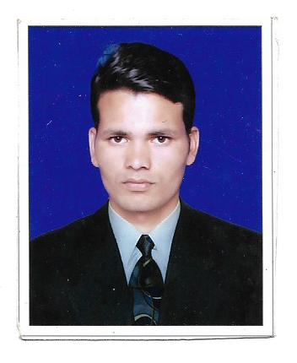
RESUME

CAREER OBJECTIVE

Make full use of my potential as an individual and a team member that would merge well with need of the firm, at the same time help my growth as a dedicated professional, along with the firm.

EDUCATION QUALIFICATION:

- B.E( Mechanical Engineer) from R.G.T.U BHOPAL- 2017
- Intermediate from U.P. Board -2013
- Matriculation B.S.E.B Patna-2011

EXPERIENCE:

- ONE YEAR ASIN PAINTS ANKELESHWAR (GUJRAT)
- SIX MONTHS S.K. INDUSTRIES GOVINDPURA, BHOPAL
- POSITION—MECHANICAL ENGINEER

RESPONSIBILITIES HANDLED:

- Responsible and self motivated .
- Ability to work effectively in team as well as individually.
- Preparation of Man power utilization & weekly/monthly maintenance reports.
- Ability to cope up with different situation

PROFESSIONAL TRAINING:

- S.K INDUSTURIES GOVINDPURA BHOPAL
- Duration -45 days

TECHNICAL SKILLS:

- Fabricators and Manufacturers
- Material Specification.

COMPUTER AWARENESS:
- MS Office (Word, Excel and Power Point).
- Internet application

STRENGTH:
- Believe in Teamwork.
- Seek challenges to perform.
- I am hard working employ with full dedication and honesty.
- Adaptability and self motivated.
- Combination of hard work and smart work.

LANGUAGES KNOWN:
- English
- Hindi

PERSONAL INFORMATION:
- Date of Birth : 10 -11- 1993
- Sex : Male
- Marital Status : Unmarried
- Nationality : Indian
- Visa status : visit (3 month visit ,expire on :12-10-2018

PASSPORT DETAILS:
- Issue Date : 10-04-2018
- Expiry Date : 09-04-2028
- Issue Place : Patna

ACKNOWLEDGEMENT:

I hereby declare that the information given here with is correct to the best of my knowledge and I will be responsible for any discrepancy.

___________________
Bipin

