RADHEESH  Computer Science Engineer  Email: radheesh.382589@2freemail.com | 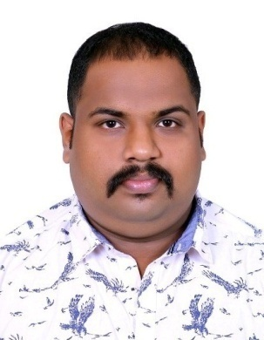
Post Applied For : System Admin
Nationality : Indian
Age and Date of birth : 2th October 1989, 28 Yrs
Sex : Male
Professional Qualifications : B.E-Computer Science and Engineering
Other Qualification : Studied Android Application Developer,
Hardware Repair, .Net
Computer skills : Proficiency in System Maintenance (Hardware
And Operating system), Microsoft office, Server Management .
Profile:

I Am a professional Engineer with 4.8years Plus experience as IT Administrator in Axis Institute Of Science & Technology Haripad, Kerala
I completed my Bachelor degree in Computer Engineering (BE-Computer Science) in 2007 – 2011
I think the skills I’ve amassed through this experience make me a great fit for Your Company, I have earned knowledge on

Job Description:
The spectrum of my roles shall include;
- Apply OS patches and upgrades on a regular basis, and upgrade administrative tools and utilities. Configure / add new services as necessary.
- Maintenance Maintain operational, configuration, or other procedures
- Create and verify backups of data
- Perform ongoing performance tuning, hardware upgrades, and resource optimization as required. Configure CPU, memory, and disk partitions as required
- Administrate infrastructure, including firewalls, databases, malware protection software and other processes
- Install and test computer-related equipment
- CCTV installation and services

Previous Experience:

5 years experience as a IT Administrator in Axis Institute Of Science & Technology Haripad, (Kerala, India)

1.3years experience as a System Admin in Istrox Research Pvt Ltd (Kerala, India)

Responsibilities include:

- Perform regular security monitoring to identify any possible intrusions.
- Provide Tier III/other support per request from various constituencies. Investigate and troubleshoot issues.
- Upgrade and configure system software that supports GIS infrastructure applications or Asset Management applications per project or operational needs.
- Maintain data center environmental and monitoring equipment.
- Repair and recover from hardware or software failures. Coordinate and communicate with impacted constituencies
- Provide technical support for both hardware and software issues our users encounter
- Support LANs, WANs, network segments, Internet, and intranet systems

I hereby declare that all the statements made in this Curriculum Vita are true, complete and correct to the best of my knowledge.

