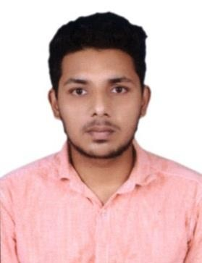
IGNETIOUS
Karama, Dubai
Email: ignetious.382603@2freemail.com
Visa status: Visit Visa

OBJECTIVE:

To seek a challenging position in engineering industry that needs innovation, creativity, dedication and enable me to continue to work in our company. With my current knowledge and fostering creativity with many learning opportunities.

QUALIFICATION:

Bachelor of Engineering in MECHANICAL ENGINEERING at RVS Padhmavathy College of Engineering and Technology with 76.5% (Affiliated to ANNA University)

HIGHLIGHTS:
- Ability to Multi-task and organize functions within any environment and given deadline.
- Disciplined and loyal.
- Good numeric ability

- An enthusiastic person with highly motivated and leadership skills having bachelors of engineering degree in Mechanical Engineering.
- Good knowledge of designing
- Eager to learn new technologies andmethodologies

EXPERIENCE:

Company: TVS SundaramFasteners Ltdunder Contract of BETS ENGINEERING (JULY 2016 to NOV 2017)
Acting role: Quality Engineer.
Responsibilities:
- To meet customer quality needs according to applications like mechanical properties.
- Check the mechanical properties of the given job as per standards and customer needs.
- Checking Sequence of operation in Heat treatment processes of Furnace
- Communicating to Works Manager regarding commitment problem, process delays and update status.
- Effective utilization of resources like man, machine & material.
- Maintain and operate the Heat treatment Sanyang furnace.
- Instant update on Quality status of part in SAP software.
- Follow up with other technician whether any kind of change of operation.
- Documentation of quality data on daily basis in Excel.
- Checking the PH and acid level in the phosphate solution.
- Reading & analyzing the drawings given as per company standards.
- To ensure whether the process control & quality standards are met.
- Preventive Maintenance and system analysis and improvisations.

PROFESSIONAL SUMMARY:
   
- Have 1 and ½ years of competitive experience in engineering industry.
- Able to handle Heat treatment process for materials.
- Able to manage system of process.

AREA OF INTREST:
- Maintenance
- Quality
- Production and manufacturing
- Designing

SOFTWARES KNOWN:

- AUTOCAD 2D&3D.
- REVIT MEP.
- MS OFFICE with specialization in EXCEL, WORD and PPT.

CERTIFICATIONS:

- AUTOCAD Certificate from Trinity ( Id :TST180206 )
- REVIT MEP Certificate from Trinity ( Id :TST180207 )

PERSONAL DETAILS
Date of Birth : | 31st July, 1995
Nationality : | Indian
Sex : | Male
Languages Known : | Tamil, English, Malayalam, Hindi.
Visa Status : | Visit Visa
DECLARATION

I hereby declare that all the above information given is correct to the best of my knowledge. I would be glad to provide any other information required by you.

