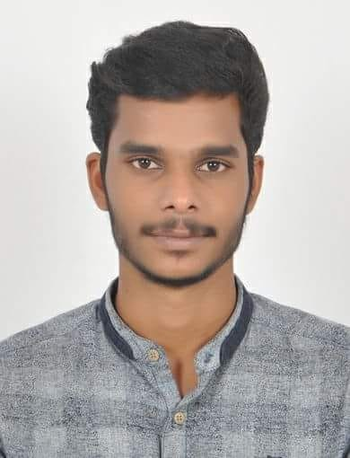
VISHAK

Email: vishak.382618@2freemail.com

Objective

Seeking a challenging opportunity in a projective organization which will allow my experience and extensive communication and organizational while providing an opportunity for career.

Skills/Professional Highlights

●Work with diverse type of people and condition.
●Communicate ideas easily

●Easily adjustable with working condition.

WorkingExperience

●Worked as HR. Office admin in dubai airport Emirates under section company transguard group of security ( 2017-2018 ) .
● Worked as HR. Office admin in Aiesys Private Limited, Technopark , Trivandrum
●Worked as HR. Office accountant postal department under Govt. of India ( 2016-2017 ) .
●Worked asAccounts Clerksin“The Vijaya Castle Hotel,Kollam ( 2015-2016 ) .

Educational Qualification

MBA from IGNOU, Catholicate College, Pathanamthitta

B.Com from Indira Gandhi National Open University

Diploma in mechanical engineering

Higher Secondary Education from Kerala HSE Board.

S S L C Education from Central Board of Secondary Education

Computer Skills

Windows os Windows Office Tally
Winhms Hospitality Management Software
Finacle Software

PersonalDetails

Nationality:India
Date of Birth:12/05/1994
Marital
Status:Single
Languages

Known:English Hindi, Malayalam& Tamil

Computer Skill

Windows OS Windows Office Tally
Winhms Hospitality Management Software
Finacle Software

Declaration

I hereby declare that the forgoing information is correct and complete to the best of my Knowledge and belief.

