Asma
E-mail : asma.382624@2freemail.com

Looking for a stable position in an established organization & to become a Reputed Personality in a stimulating & challenging working environment.
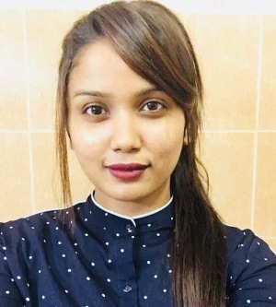
Profile Summary
- Profound knowledge of IATA regulations
- Operational knowledge of CRS System Abacus, Galileo and Worldspan
- Sound knowledge of Amadeus and Sabre
- Solid ability to handle reservations by assigning flights and ticketing
- Proven ability to work to deadlines
- Excellent communication skills
- Work effectively under pressure and the ability to work as a team and be result oriented.
- Pro-activeness and problem solving skills.
- Dedicated and detailed — high level of accuracy and strong attention to detail.
- Demonstrated ability to work independently, perform under pressure, multitask on several assignments, and meet strict deadlines.
- Well organized, quick learner and dedicated team player.
- Well versed with MS Office.
- Seeks a rewarding career to share and enrich knowledge and experience.

Experience Snapshot
- Reservations Executive
FindMyFare – Colombo 03 (Since Augusts 2015)

- Answering phone calls and giving information to passengers as per their travel plans
- Using airline's computer system for checking flights, fares, and new updates
- Handling questions, complaints, and inquiries from customers politely and discreetly
- Instructing customers on using company website and mobile application for information
- Taking customers' information and feeding in the computer systems and making reservations
- Applying discounts on tickets for regular customers and assisting in hotel reservation and car renting

- Reservations Executive
Shri Shaaya travels (pvt) ltd (Colombo 4)

- Worked well to achieve targets and ensured that all queues and updates were regularly checked.
- Utilized all preferred Airline contacts.
- Assigned flights to the cruise system and ensured that allocations were used.
- Handled internal and external calls, offering the highest level of customer service.
- Issued airline tickets for bookings in line with contracts.

- Reservations Executive
MPS Travels and Tours (Colombo)

- Provided options to customers for air travel and accommodate their travel needs
- Relayed correct, complete, and updated information on flight schedule, fare, arrival, and departure to customers
- Processed credit card, check, and cash payments for sold tickets for walk-in customers
- Coordinated with hotel and car rental agencies and extended services to customers
- Made alternate arrangements for passengers owing to flight cancellation and processed refund as required

Professional Qualifications
- Successfully completed the Diploma in Airline Ticketing conducted by Airline Ticketing Academy-Colombo (Mr.Deepal Perera)

- Followed a Diploma in English
(LBS) Colombo
Education Qualifications

- A/L (General Certificate of Advanced Level Examination)
Completed General Certificate of Advanced Level in year 2013
- O/L (General Certificate of Ordinary Level Examination)
Passed General Certificate of Ordinary Level in year 2010

Personal |  | Details
Nationality | : |  | Sri Lankan
Date of Birth | : |  | 22th of June 1994,
Visa Status | : |  | Tourist Visa (valid 30 days)
Languages | : |  | English/Malay & Sinhala

