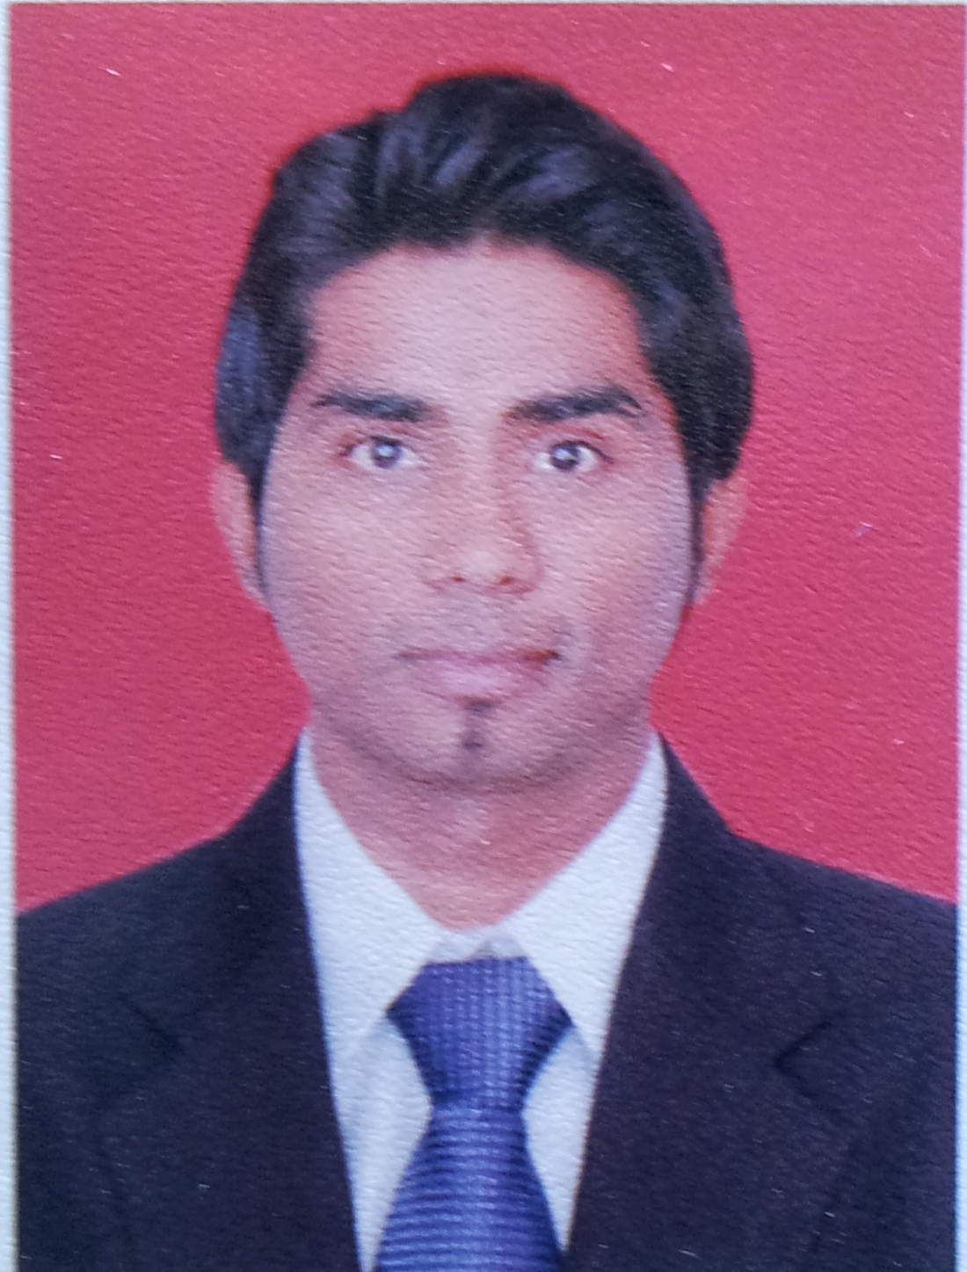
RESUME

RANJIT .R.GUPTA
Marcel-Goa, India Pin code 403107
E-mail ID: - ranjitgupta1989@gmail.com
Dubai CONTACT NO +971 52 289 4384

CAREER OBJECTIVE:
To be efficient and effective in the areas of work assigned to me

WORK EXPERIENCE:
01.
Duration | September 2011 to 30 July 2012
Company | Samsung Mobiles Pvt. Ltd-Panaji Goa
Designation | Samsung Business Associate
Responsibilities included:
- Samsung Smartphone & Basic phone sales.
- Daily Stock Checking.
- Creating Daily Sales report in Samsung sales book.

02
Duration | 3rd August 2012 to 30 October 2013
Company | Vodafone Pvt. Ltd -Panaji Goa
Designation | FSO (Field Support Officer) Data Support
Responsibilities included:

- Resolving customer complaints of internet
- Troubleshooting and problem resolution of data card and mobile GPRS
- Sending daily report to Manager

03. Worked in Casino Pride-2, Goa as a CASHIER from 10 March 2014 to 31 March 2015.
04 Worked in Deltin Royal (Delta Corp) as a CASHIER from 16 may 2015 to 30 November 2015.
- Worked for OPPO MU mobile Pvt. LTD as a Oppo Sales Representative from 6th February 2017 to 18 Dec 2017.

Responsibilities included:
- OPPO Smartphone sales.
- Daily Stock Checking.
- Creating Daily Sales report & sending to TL

- Presently working with Kuwait Food Company-Americana- Dubai-UAE branch as a Team member in the operation department from 8 February 2018 to till Date.

Other: Worked for 40th, 41st, 42nd, 43rd, 44th, 45th & 47th International Film Festival of India, As a Festival Executive, held in Goa-India.

EDUCATION:
Exam | Year of passing | Institution | Percentage
SSC | March 2005 | Goa Board | 50%
HSSC | March 2007 | Goa Board | 58%
JETKING (Computer Hardware & Networking Institute) | 2012 | Jetking Institute-Panaji | 'B’’ Grade

Summary of Additional Skills and Qualification:
- Knowledge of MS Office, Internet, Know to use other Software’s etc.
- Installation of Windows XP/Vista, Windows 7, Window-8, Windows-10.
- Computer Troubleshooting/repair, Basic in Networking.
Strength
- Good Communication skill
- Hardworking
- Quick Learner
- Humorous

PERSONAL PROFILE:
Name : Ranjit Gupta
Date of Birth : 06 October 1989
Fathers Name : Rajendra Gupta
Sex : Male
Marital Status : Single
Religion : Hindu
Languages : English, Hindi, Marathi, Konkani
Nationality : Indian
Permanent Address : H.No:903 Khadap-Wada, Kumbharjua, Tiswadi – Goa INDIA
Present Address : Al Rigga,Dubai UAE

Passport Detail : Passport No :-K1753438
Place of Issue :- PANAJI-GOA
Date of issue :- 13/07/2012 Date of Expiry :-12/07/2022

I declare that all the information stated above is true & correct to the best of my knowledge. 