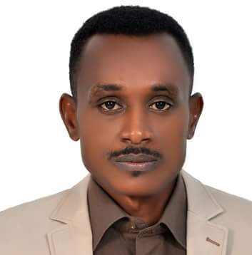
^{Resume of,}Khalid
- Email Address: Khalid.382639@2freemail.com

Career Objective
One of the favorites is that working in full capacity environment in order to achieve the stated objective of the organization as much as possible & continuously enrich personal skills & ability.
Work Experience 8 Years
- Organization Name: Rae Company for Environmental Services
Position: Entomologist
Duration: 4th February 2013 to 4th February 2018 (Five years)
Address: Holy Makkah, Saudi Arab
(IPM- Bioassays - Susceptibility Tests -Monitoring, evaluation of PC Companies)
- Organization Name: Smart Prevention for Mainte.&Cleaning E.st
Position: Pest Control (Supervisor- Operations manager)
Duration: 19th May 2011 to 30th January 2013 (Year &eight months)
Address: Taif City, Saudi Arabia
(IPM -Inspection, Monitoring& Control measures, Supervision, Reporting)
- Organization Name: Yaser Mahajoub for Cleaning & Services Co.Ltd
Position: Health Officer (Assistant Operations Manager)
Duration: 1st May 2009 to 10th May 2011 (Two years)
Address: Capital Khartoum, Sudan
Solid Waste Management (Collection, Transport, Recycling, EHS, Pest Control)
Educational Qualifications | Skills & Abilities
-B.Sc. in Health & Environmental Sciences  from University of Gezira, Sudan in the  Year 2009. Attested by UAE Embassy and  Higher Education Commission of Sudan  -Attended several courses related to  Environment health, Public Health, Pest  Control (IPM), Profession Ethics. | Communication skills:  - Arabic ( Native Speaker)  - English (Good)  Computer Skills:  - MS Word, PowerPoint, Excel  - Internet, other application  KSA driving license

References and all Certifications are available on request.

