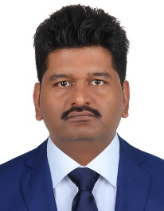
Salman

E-mail: salman.382713@2freemail.com
Driving License: Oman (Light Vehicle)
Objective
Get an honorable position in a growing organization where my as a Service Engineer skills along with my Experience and Study will provide an opportunity to make valuable contribution to an organization.
Qualification

Degree | Session | Board
Metric | 1997 | B.I.S.E Lahore
F.A. | 1999 | Private

Skills
Installation Driver of Scanner Copier and Printer in LAN \Wireless base networking.
As a Photocopiers technician fault finding mechanical and electronically problems.
Try to Repair the fault at customer location.

Experience

As a Senior Photocopier/Printer Service Engineer having 18 years’ experience in these Brands Konica Minolta, Canon, Sharp, Ricoh and Kyocera Mita Multifunctional System from 20 Copy speed to 105 Copy per Minute Color and Black Units.
Languages

Frequent in English, Arabic, URDU, Punjabi, and Marwari.

Working Experience

Working | Company | Experience
Senior Service Engineer | Leading Edge Computer | January 1998 To September 2001
Field Service Technician | Husun al Debaishi Trading and Contracting  Muscat Oman | September 2001  November 2006
Field Service Technician | Madina Al Manama L.L.C Ruwi Oman | January 2006  August 2011
Field Service Technician | Shatti Na’ammah L.L.C  Sur Oman | November 2012  June 2014

Personal Information
Date of birth | 28/11/1977
Religion | Islam
Status | Married
Nationality | Pakistan

