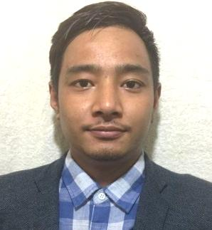

NIMTEMBA

Dubai, U.A.E

E-mail: nimtemba.382831@2freemail.com

aPPLICATION FOR THE POST OF:any suitable post
objective

Seeking for substantial responsibility where my past and varied experience would be fully utilized in a career opportunity and where making a significant contribution to the success of my employer which will gain me a career advancement opportunity.
Work Experience

- Presently working as a Sales Man at Gym a Food Industries, Dubai, UAE, from 2016 to till date.
- Worked as a Call Center at Wipro Call Center, Kolkata, India, for 9 Months.
EDUCATIONAL QUALIFICATION
- +2 Passed
passport details
Date of Issue : 16/03/2015
Date of Expiry : 15/03/2025
Place of issue : Kolkata, India
Personal Details
Date of Birth : 14/04/1989
Nationality : Indian
Religion : Buddhist
Gender : Male
Marital Status : Single
Language Known : English, Hindi, Bengali &Nepali
Visa Status : Employment Visa
declaration
- I certify that all the details provided above are all correct according to my knowledge and belief.

