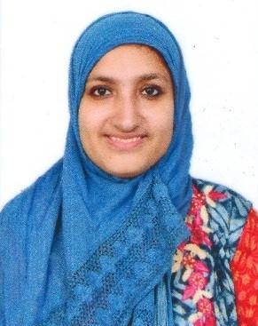
Farheen

Email Id: farheen.382848@2freemail.com

_____________________________________________________________________________________

Carrier Objective

To work in a healthy, innovative and challenging environment extracting the best out of me, which is conducive to learn and grow at professional as well as personal level thereby directing my future endeavors as an asset to the organization.

Job Profile

Worked as Trainee Engineer

Major Job responsibilities during this period comprised of-
- Submission of quotations and offers ( maintenance, budgetary and project offers)

- Attending customers and sales representative calls related to techno commercial queries on offers submitted
- Following up with the offers submitted to the customers

- Technical Sales Support Activities

- Overall Marketing Management

Educational Qualifications

- Currently pursuing MBA from Sikkim Manipal University and has completed 1st semester

- Bachelor of Engineering (Electronics and Telecommunication Engineering) at Agnel Institute of Technology and Design, Mapusa Goa passed out with passing percentage of 68.16% in the year 2016

- HSSC from St Xavier’s Higher Secondary School with passing percentage of 65.66% in the year 2012

- SSC from St Francis Xavier High School with passing percentage of 68.66% in the year 2010

Experience
- 10 months experience in Pyro Electric Instruments Goa

- 6 months experience in Samsung Service center as Service Engineer

Courses Attended
- Embedded System using 8051 Microcontroller

- Network Implementation and Security

- Soldering and PCB designing workshop

- Introduction to Embedded Systems with AVR

- Android Apps Development

- Indian Engineering Olympiad

Internships

- Completed 2 weeks Internship at Rishabh Industries ( 30th June 2014 to 12th July 2014)
- Completed 2 weeks Internship at Centre of Incubation and Business Acceleration ( 29th June 2015 to 11th July 2015) Worked in the Android Domain

Project

Worked on the Electronic Glove

Personal Strengths
- Quick learner, focused and achievement oriented

- Self motivated with good interpersonal and communication skills

- Flexible and dedicated to the company’s objectives

Technical Skills
- C, C++, Java

- Embedded Systems

- MS OFFICE (MS Excel, MS Word, MS PowerPoint etc)

Interests
- Singing

- Reading

- Playing Badminton

Personal Profile

Nationality

: Indian

Sex

: Female

Marital Status

: Single

Date of Birth

: 28th February 1995

Declaration

I hereby certify that all the information provided here is correct to the best of my knowledge and belief and I promise to abide by all the norms laid down by your esteemed organization.

