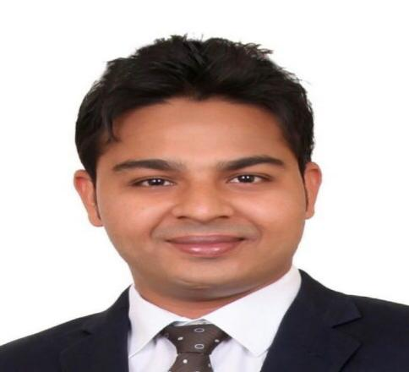
Sohail
Email : sohail.382868@2freemail.com
Address : Dubai, UAE
Visa Status : Employment

CAREER OBJECTIVE

I am a person who cherishes challenges and aspire to seek excellent in the task assigned to me.
To work in organization that offers a creative, dynamic and professional skill and proven
Abilities can be fully applied to benefit the organization and myself simultaneously.

STRENGTHS

- Able to work on my own initiative and as part of a team.
- Solid expertise in sales, business development processes, and marketing
- Attended various sales seminars
- Highly skilled and well organized in providing customer service and order processing
- Possess an active, energetic, and lively personality, with the ability to engage customer interest and attention
- Outstanding written and oral communication skills
- Proficiency in MS word, MS access, Power Point and other computer applications
- Quick learner
- Good listener

Etisalat Telecommunication,Dubai-UAE

As Sales Executive (July 2017 to Present)
- Identifying, qualifying, and securing business opportunities
- Building business relationships with current and potential clients
- Developing customized targeted sales strategies
- Coordinating business generation activities
- Responding to client requests for proposals.
- Answering potential client questions and follow-up call questions
- Creating and maintaining a list/database of prospect clients
- Maintaining short- and long-term business development plans
- Cold calling, making multiple outbound calls to potential clients
- Understanding client needs and offering solutions and support
- Researching potential leads from business directories, web searches, or digital resources

National Trading and Developing Est. Dubai-UAE
As Retail Sales Associates and Customer Service (September 2015 to June 2017)
Responsibilities

- Maintained friendly and professional customer interactions at all times.
- Strategic consulting, including business plan and sales strategy development.
- Social Media Marketing.
- Customer relationship management.
- Cash Handling
- Physical Stock Checking

Hindustan Unilever, Gujarat-India.
As Sales Executive (April 2012 to Aug.2015)

Responsibilities
- Manage company’s largest region with full sales cycle responsibility, from initial contact to closing, follow-through, and servicing
- Manage around 300 accounts
- Educated and sold customers on the benefits of various products
- Expanded and controlled both new and existing accounts
- Studied and recommended alternatives to clients
- Answered any inquiries raised about pricing and availability

ACADEMIC EDUCATION
- Bachelor’s Degree (Bachelor of Commerce 2012)
(Maharaja Sayajirao University of Baroda,Gujarat-India)

- Higher Secondary School Gandhinagar
(Higher Secondary Education Board Gandhinagar,Gujarat-India)

CERTIFICATION/ ADDITIONAL SKILLS:

- P.O.S (Point of sale)
- Microsoft Office
- Tally Software
- Quick book

PERSONAL INFORMATION:
- Date of Birth : May, 8th 1990
- Nationality : Indian
- Marital Status : Married

LANGUAGE

English, Hindi, Gujarati, Urdu

