ATHIRA
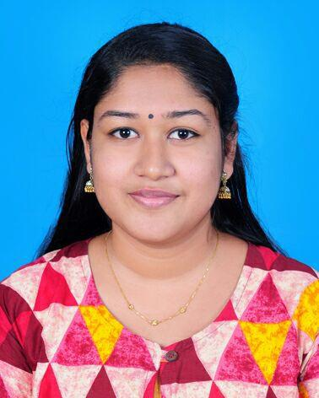

Contact Information:

Email:

Athira.382879@2freemail.com

PASSPORT DETAILS

Place of issue | : | Cochin
Date of issue | : | 04/06/2018

Date of Expiry : 03/06/2028

Status: visit visa

Personal Information:

Date of Birth : 06 July 1994

Gender : Female

Marital : Single Status
Languages : English

known Hindi Malayalam

Objective

To Build a Career with leading Corporate Environment with Committed and Dedicated People, which will help me to explore myself fully and realize my potential. Also willing to work as a key Player in Creative Environment.

Profile Summary

- Customer Oriented, Multitasking fresher with MBA degree in HR/Marketing.

- Expert in Understanding the Business Requirement.

- Excellent in identifying the need of Organization.

- Excellent in understanding and analyzing the Human Behavior.

- Proficient in coordinating with the People.

Core Competencies

- Sound knowledge of HR working.

- Good Command Over HR Concepts.

- Familiar with working of MS Excel.

- Problem Solving Skills.

- Can Work Under Pressure.

- Target Oriented.

- Quick Learner.

ACCOLADES

- Event Head of HR game in TANTRA 2K16, All India level Management fest conducted by MACFAST MBA Department.

- Attended Industrial visit conducted by MACFAST at COGNIZANT, RBI, UST Global Sud Cheme and Central Travancore of Fisheries and Technology 2015.

- Attended PRAGMATIX training Class.

- Attended YES PLUS Course Conducted by Art of Living.

- Attended Research Methodology Workshop by Dr Venkata Subramanyam CV.

Academic/Professional Qualifications

- HR & Marketing in MBA from MACFAST college, Thiruvalla (2015-2017) with 70% percent.

- BBA from SNGM College Thuravoor. (2012-1015) with 75% percent.

- Pre-University from N.S.H.S.S MANNAR (2012) with 84% percent.

- 10th standard from S.B.H.S.S MANNAR 2010 with 90% percent.

Academic Project

- A study on employee welfare measures at the ALUMINIUM Industries ltd, Switchgear Mannar.

- The main objective of this project is to know the various welfare activities provided to the employees by ALUMINIUM Industries ltd, Mannar.

- A report on Organization study at ALIND, Mannar.

COMPUTER SKILL

- MS OFFICE

- EXCEL

DECLARATION

I hereby declare that the above furnished details are true to my knowledge and its accountability lies solely with me.

