ABHISHEK

E-mail: abhishek.382881@2freemail.com

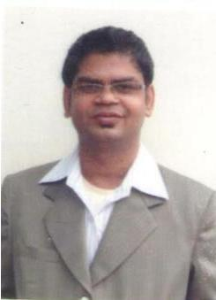

Career Objective: Seeking opportunities in the area of customer relationship management, data management in a reputable organisation to be able to utilise my skills and experience.

Profile Summary: Detail Oriented worker with strong communication skills. Experienced in customer service profiles as well back-office data management.

ORGANISATIONAL DETAILS

Worked as Customer Relationship Officer with Fino Payments Bank Patna from Nov 2017 till July 2018 Fino Payments Bank is one of the newest and fastest growing banks which caters to all banking needs. Job Responsibilities
- Responsible for assigned sales targets (monthly, quarterly and annually).

- Cold calling to arrange meetings with potential customers to prospect for new business

- Responding to incoming mails and phone queries

Achievements
- Generated new business in terms of signing up new clients

Worked as Data entry operator in Gita Mahila Uthan Samity – Aug’15 till Oct’17

Job Responsibilities

- Ensured entered data accuracy by comparing with basis documents and identified errors.
- Performed modifications, edits and deletions to the database based on authorized and approved documents.
- Routed data to appropriate staff for follow up and additional review.

Internship
Organization: Aryan News

Worked in Input desk for 6 months
- Collected news & videos from the various sources
- Sorting & reviewing of data for final review by the editorial team

Educational Qualification:

- B.Sc. (Mass communication & Journalism) from PTU with 63.11% in 2015
- XII (PCMB) from BSEB, Bihar in 2008

- X from BSEB, Bihar in 2005

Technical Qualification:

- Diploma in Computer Application

Computer Literacy

- Well versed with all Computer Fundamentals i. e. MS-Office, Internet

 | Personal Details:
●
● |  | Date of Birth: |  | 9th Dec 1990
- Marital Status: Unmarried

