MAHENDRAN
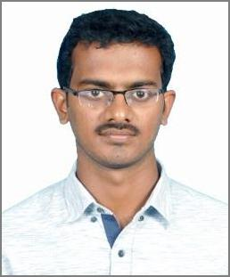

Sharjah, UAE.

Mahendra.382887@2freemail.com

Career Objective

To work in an innovative and challenging environment which gives an opportunity to learn more and I will execute my skills at the level of best for the company's growth.

Experience Details

2 years of experience in Site Engineer:

Organization : Sri Guru Constructions, Chennai.

Period : May 2015 to April 2017

1 year experience in AutoCAD Draftsman:

Organization : Saanvi Structurals, Chennai.

Period : April 2017 to June 2018

Summary

- Experienced in preparing AutoCAD drafting for construction projects.

- Completion of buildings as per drawings from foundation to finishing.

- Preparation of RA bills according to the approved BOQ of the projects and find out the Quantity deviations.

- Study of architectural & structural drawings.

- Making Bar bending Schedule as per drawing.

- Taking care of quality of materials for Concrete.

- Co-ordinate with Architect, PMC and Structural consultant.

Projects Handled

- Ultra luxury Row houses at Kolapakkam, Chennai (G+2, 14Plots).

- Hostel Construction at Navalur, Chennai (G+4).

Software skills

- Auto CAD

- STAAD.Pro

- MS Office

Educational Qualification:

- B.E. Civil Engineering from Dr.Sivanthi Aditanar College of Engineering, Anna University Chennai in year 2015.

- HSC from H.N.Hr.Sec.School, Kadambur, Tuticorin(Dt) in year 2011.

- SSLC from H.N.Hr.Sec.School, Kadambur, Tuticorin(Dt) in year 2009.

Self Evaluation

- Ability to work hard and handle crisis situation & face challenges.

- Capable of working independently and in a team.

- Can follow rigid time schedules and capable of taking up responsibilities.

Personal Details
Date of Birth |  |  | : | 18-07-1994
Languages known |  |  | : | English, Tamil, Telugu, Malayalam
Visa Status |  |  | : | Visit Visa
Declaration

I declare that the information furnished above is true to the best of my knowledge.

