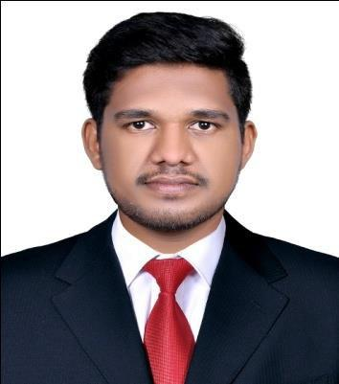
Shefin

Mechanical Engineer

Dubai, UAE

Email: shefin.382946@2freemail.com

CAREER OBJECTIVE

Seeking a position to utilize my knowledge, skills, and abilities in the industry that offers competitive environment, a true profession to put in the acquired knowledge and gain exposure to upcoming technologies while being resourceful, innovative and flexible.

EXPERIENCE

Total Experience – 3 Year 6 Months

Maintenance Engineer
Reliance Jio Infocomm Ltd
Trivandrum,Kerala
(Jan 2018 –July 2018)

Key responsibilities handled:
- Close inspection of work in site & progress.

- Knowledge of basics in HVAC and firefighting.

- Manage and support Engineering technicians & Soft servicing group towards company s target.

- Handling customers nd clients

- Preparation of daily report and manpower allocation.

Facility Supervisor (mep)

Al Majal Alarabi group Holding Riyadh KSA Client – Al Qassim University
Kingdom of Saudi Arabia

(2015 – 2017)

Key responsibilities handled:
- Handling Customers and Clients

- Manage and support Engineering technicians & Soft servicing group towards company’s targets.

- Responsible to monitor all the assets of the buildings as per Company & client Standards.

- Reporting to the Site Manager on daily basis.

- Responsible for 24hours Emergency Maintenance service.

- Attending customer complaints and suggesting them with an appropriate solution for their issues.

MEP Engineer
Career comfair pvt Ltd
Cochin Kerala, India

(2014 – 2015)

Key responsibilities handled:

- Knowledge of basics in HVAC and firefighting.

- Close inspection of work in site & progress.

- Checking the pipe supports, eccentric, concentric, reducers, joints, perfect insulation without leakage.

- Preparation of daily report and manpower allocation.

- Witnessing the three stage of welding test.

- Attending site meeting with government authorities and taking actions for the requested problem for work.

- Preparing back charges for damages and submitting it to the project manager.

- Ordering the required materials as per specifications.

EDUCATION

Bachelor of Technology : Mechanical Engineering
Sri Acharya University, Vijayapura.

(2010 – 2014)

XII: Biology Science
Kerala Higher Secondary

(2008 – 2010)

X
SSLC
(2008)

CERTIFICATIONS
- Diploma in MEP/HVAC

- Diploma in Piping & pipe line engineering

- Diploma in NDT QA/QC – ASNT LEVEL II Certification

PERSONAL DETAILS

Gender |  | : | Male
Date of birth |  | : | 20/11/1991
Nationlity |  | : Indian
Languges known |  | : Arabic,English,Hindi,Malayalam
TECHNICAL SKILLS
• | Operating Systems |  | : Windows 8, Windows 7, Windows XP, Linux
• | Office Package |  | : Microsoft Office Package - M.S Word, Excel, PP

DRIVING LICENSE DETAILS

Saudi Arabia

Date of Issue - 31/05/2016

Date of Expiry – 06/04/2021

India

Date of Issue – 26/07/2010

Date of Expiry – 12/06/2030

PASSPORT DETAILS
Date of Issue | : 13-June-2012 | Date of Expiry : 12-June-2022
Place of issue | : Trivandrum

DECLARATION

Thank you for going through my CV. I would be very much obliged if I am given an opportunity for a personnel interview at a time convenient for both of us, so that I can prove my mettle and give you more detail about myself.

With earnest regards,

