Curriculum vitae
Irdris

Email: idris.383028@2freemail.com /Dubai- United Arab Emirats

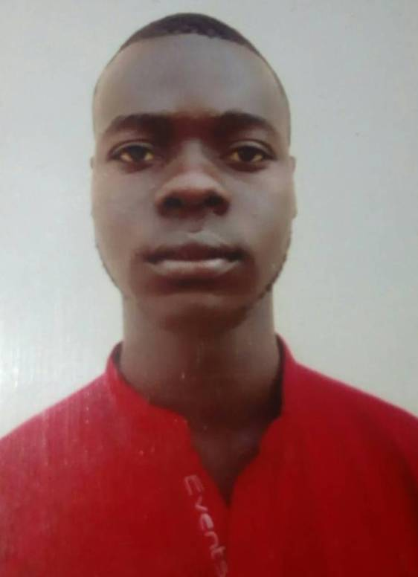
Post is applying for Security Gurard

Personal Information
Full Name: Idris
Date of birth: 19th May 1992
Martial Status: Single
Visa Status: Tourist Visa

Objective
Seeking a challenging security guard where my knowledge, skill sand work experience could be utilized in the most productive, innovative & resourceful manner and also provide growth, training and career development opportunities.

Key competency
- Highly trained in military & social permits
- Takes a comprehensive approach to every task
- Excellent customer service skills in English
- Can work in stressful, high pressure situations
- Ability to make progress on multiple assignments under time constraints
- Highly dependable, punctual & efficient
- Expert in anticipating and responding to customers' needs
- Able to represent a company with a professional appearance and manner
- Enjoy my work and consistency greet customers with a smile

Professional experience
3 years worked as a security guard at Skye bank plc in Nigeria
2 years worked as Security guard at Oyo State gulf gulf house in Dubai

Responsibilities
- Watching out for, reporting and dealing with suspicious or unusual activity
- Observe, investigate and apprehend violators of laws and public safety
- Take immediate action upon discovering illegal activity
- Reporting any incidents of concern to the head office
- Monitoring and authorizing entrance and departure of visitors.
- Locking up premises and making sure that the gates are secured
- Dealing with emergencies as they arise.
- Answering telephone calls and providing information
- Providing information to clients by answering questions, offering assistance
- Meeting and greeting official visitors
- Health & safety checks

Education / Courses
OND in Civil engineering
Computer application and internet browsing

Hobbies

- Reading Books
- Sports
- Travelling

I hereby declare that the information furnished above is true and correct to the best of my knowledge.
Idris

