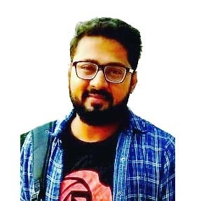
CURRICULUM VITAE

SHANTANU

E-Mail Id: shantani.383030@2freemail.com
Address: Dubai, UAE.

OBJECTIVE:
To obtain a challenging position where I can use my skills and knowledge of different travel destination, customer service and marketing which will complement my skill and help me grow further in my career
PERSONAL INFORMATION:

DATE OF BIRTH : 01th April1993
GENDER : Male
MARITAL STATUS : Single
NATIONALITY : India
VISA STATUS : Visit Visa

TRAINING

- Company Name : Touraids i
- Role : Operations
- Duration : 60 Days
- Location : Agra

Working Experience:

Employer : Freenlance ( Tour Guide)
Location : India ( Agra, UP)
Designation : Tour Guide
Period : 1 One

EDUCATION QUALIFICATION:

- MBA ( International Tourism Business)
Indian Institute of Tourism and Travel Management
- B.Com
- Senior Secondary School

SKILLS:

- Team work skills and a quick learner
- Handling Social Media Platform
- Flexible enough to fit in any situation
- Able to perform Multitask and Event Management

LANGUAGE SKILLS:

- English, Hindi

DECLARATION:
I certify that the above information is true and correct to the best of my knowledge and ability. If given the chance to serve you, I assure you that I will do my utmost best to execute my duties to the best of my abilities and to provide satisfaction to my superiors.

