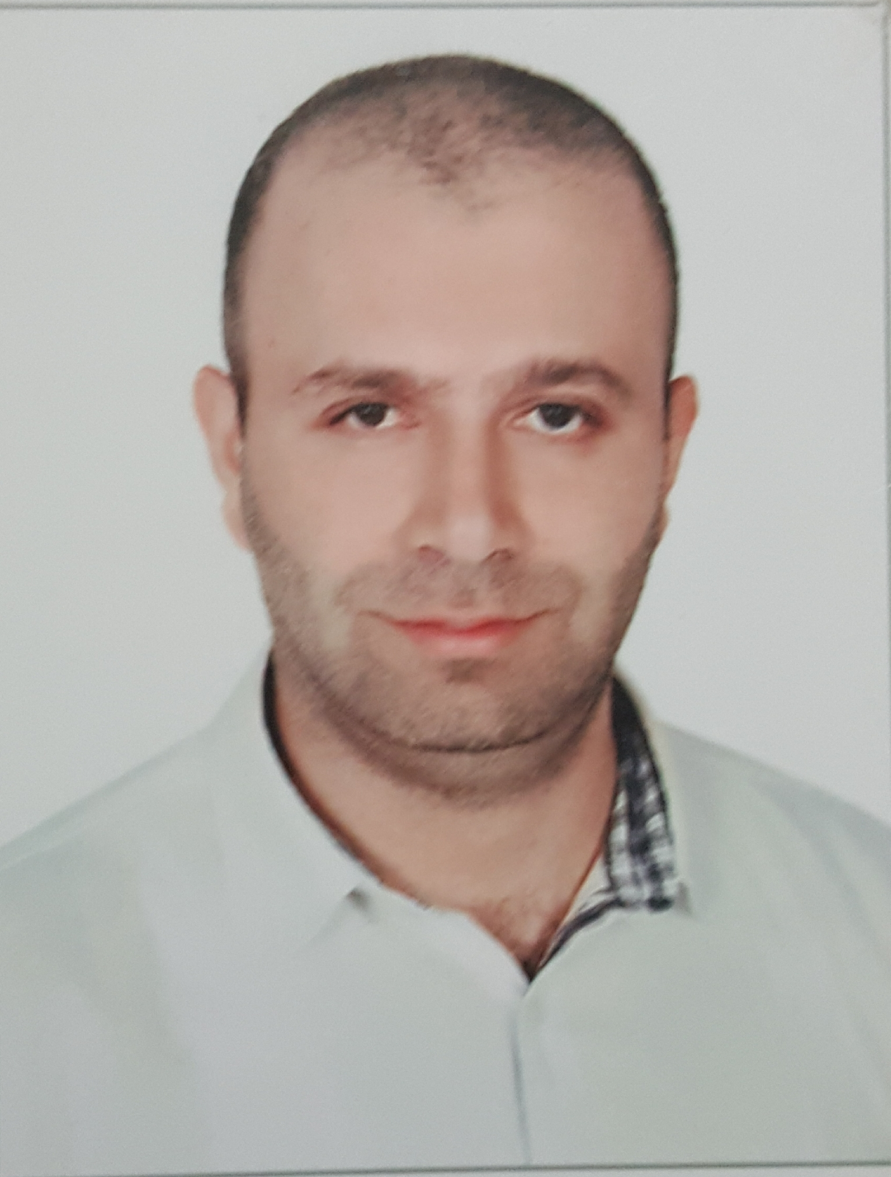
Talal

Operation Manager at Alpha Tours

United Arab Emirates

Dubai

EMAIL: talal.383068@2freemail.com

 Place of Birth : Kornayel, Lebanon
 Date of Birth : 19/09/1980
 Sex : Male
 Marital Status : single
 Nationality : Lebanese

Belarusian National Technical University

Experience:

- operation executive
- Company NameALPHA TOURS
- Dates EmployedSeptember 2006 till September 2009
Employment Duration3 years
- LocationUnited Arab Emirates Dubai Building Burlington Tower Business Bay.

Responsibilities & duties

- Arranging the transfer of all our customer, sending and confirming the transportation request with our supplier.
- Preparing the schedule of the arrival list, and assigning airport representative accordingly.
- Working with the hotels, and other transport company for groundhandling.in order to execute the arrangement
- Coordinate, communicate follow up ,in order to secure a smoothly operation .
- Book and confirm all the services required , ( VIP lounge , marhaba service, rent a car )

- CustomerServices
- Company Name ALPHA TOURS
- Dates Employed September 2009 till October2011 Employment Duration 2years
- Location United Arab Emirates Dubai Building Burlington Tower Business Bay.

Responsibilities & duties

- Deal , and help resolve any customer complaints.
- Assist and guide our cient,and provide them necessary information to fulfill their requirement.
- Receiving complain from our agent , investigate and checking with our drivers and supplier
- Sent our feedback to the agent, and offer compensation if any.

Transportation manger
- Company Name ALPHA TOURS
- Dates Employedoctober2011till august2013
Employment Duration2years
- Location United Arab Emirates Dubai Building Burlington Tower Business Bay.

Responsibilities & duties
- Managing theexecution , and coordination for all transportation maters with our supplier.
- Organizing schedule androute, ensuring that vehicle are safe ,and meet legal requirement.
- Dispatching driver and assigning their job order.
- Inform our drivers regarding their job order, and making sure that driversare aware of their duties

- Operation manager
- Company Name ALPHA TOURS
- Dates Employedaugust2013 till present
Employment Duration 5 years
- Location United Arab Emirates Dubai Building Burlington Tower Business Bay.

Responsibilities & duties
- Senior role , which involve overseeing the provision of services.
- Ensure that the day to day operation of a business run efficiently.
- Oversee the supervision of employees.
- Motivate employees.
- Set goals and objectives for various department corporation with other mangers and help
- Establish procedure and put them into effect.
- Supervising and training other employees.
- Monitoring existing process and analyzing their effectiveness.
- Creating strategies to improve , the best service.

Education:

- Software engineering Bachelor Degree at Belarusian National Technical University (BNTU) – 2004.
- Software engineering Master Degree at Belarusian National Technical University (BNTU) – 2005.

Languages:

Arabic: Fluently
English: Fluently
Russian: Fluently
French: Fluently

