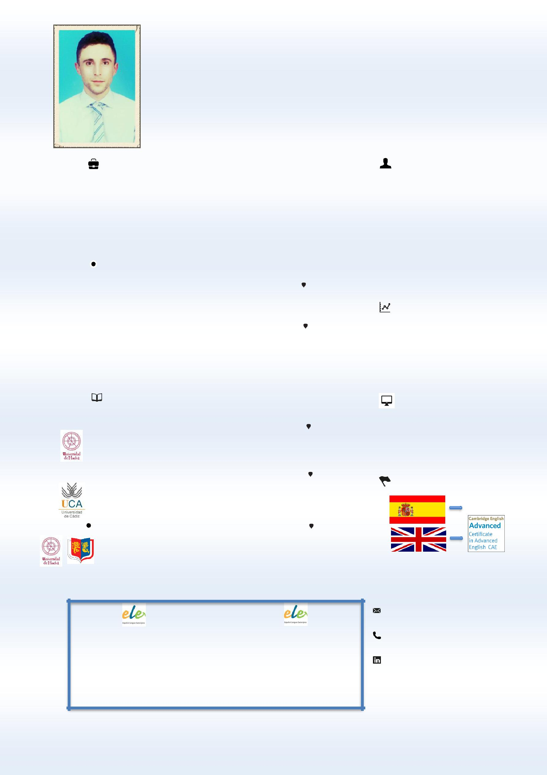
FELIPE

SPANISH TEACHER

WORK EXPERIENCE

ABOUT ME

2016 - Present

2015 - 2016

SPANISH TEACHER
EP DEPARTMENT, STRISUKSA SCHOOL ^{Roi Et, Thailand}
Lessons of Spanish as a Foreign Language at the English Program in Strisuksa Secondary School. M1 to M6 level. In charge of the cultural workshops in Hispanic culture.

ENGLISH TEACHER

SAFE LANGUAGE SCHOOL
Huelva, Spain

Dedicated and enthusiastic language teacher with experience in different countries. Passionate about linguistic and cultural studies. Fond of literature, art, sports and food.

2010 - 2011

2015 - 2016

2011 - 2013

2006 - 2012

English lessons in a languages school. A1 to C1 level.

Preparation of official exams.

SPANISH TEACHER | Warsaw, Poland
ACADEMIA ESPAÑOLES

Lessons of Spanish as a Foreign Language in a language academy. A1 to C1 level. Preparations of official exams. Workshops in Hispanic culture.

EDUCATION

Masters Degree in Secondary Education | Spain
University of Huelva
Language Teaching for Secondary School students.
Masters Degree in Audio Visual Translation | Spain
University of Cádiz
Subtitles, Dubbing and Software Localization. Translation of Movies
and Videogames.
Bachelor’s Degree in English Philology | Spain, UK

University of Huelva / University of Birmingham

English Language and Literature. Linguistic Studies in English and Spanish.

SKILLS

- Creative
- Dynamic
- Resourceful

- Efficient

COMPUTING

  - Microsoft Office
- CAT tools
- Aegisub

- Virtual Subsync

LANGUAGES

MOTHER TONGUE

CONTACT ME

SPECIALISATION

- TRAINING COURSE FOR ELE TEACHERS. Cervantes Institute. ONLINE COURSE IN ELE TEACHING. University of La Rioja.

- TRAINING PROGRAM IN ELE TEACHING. University of Valladolid.

Felipe.383098@2freemail.com

