RESUME

SURENDRA

Email :

Surendra.383153@2freemail..com

Personal Information:

Gender : Male.

Date of Birth : 04/01/1992

Marital Status : Single

Nationality : Indian.

Languages : English, Hindi

Kannada, Tulu.

Passport Status:

Validation : 2017-2027

Visa Status :

On ‘Visit visa’

Career Objective:
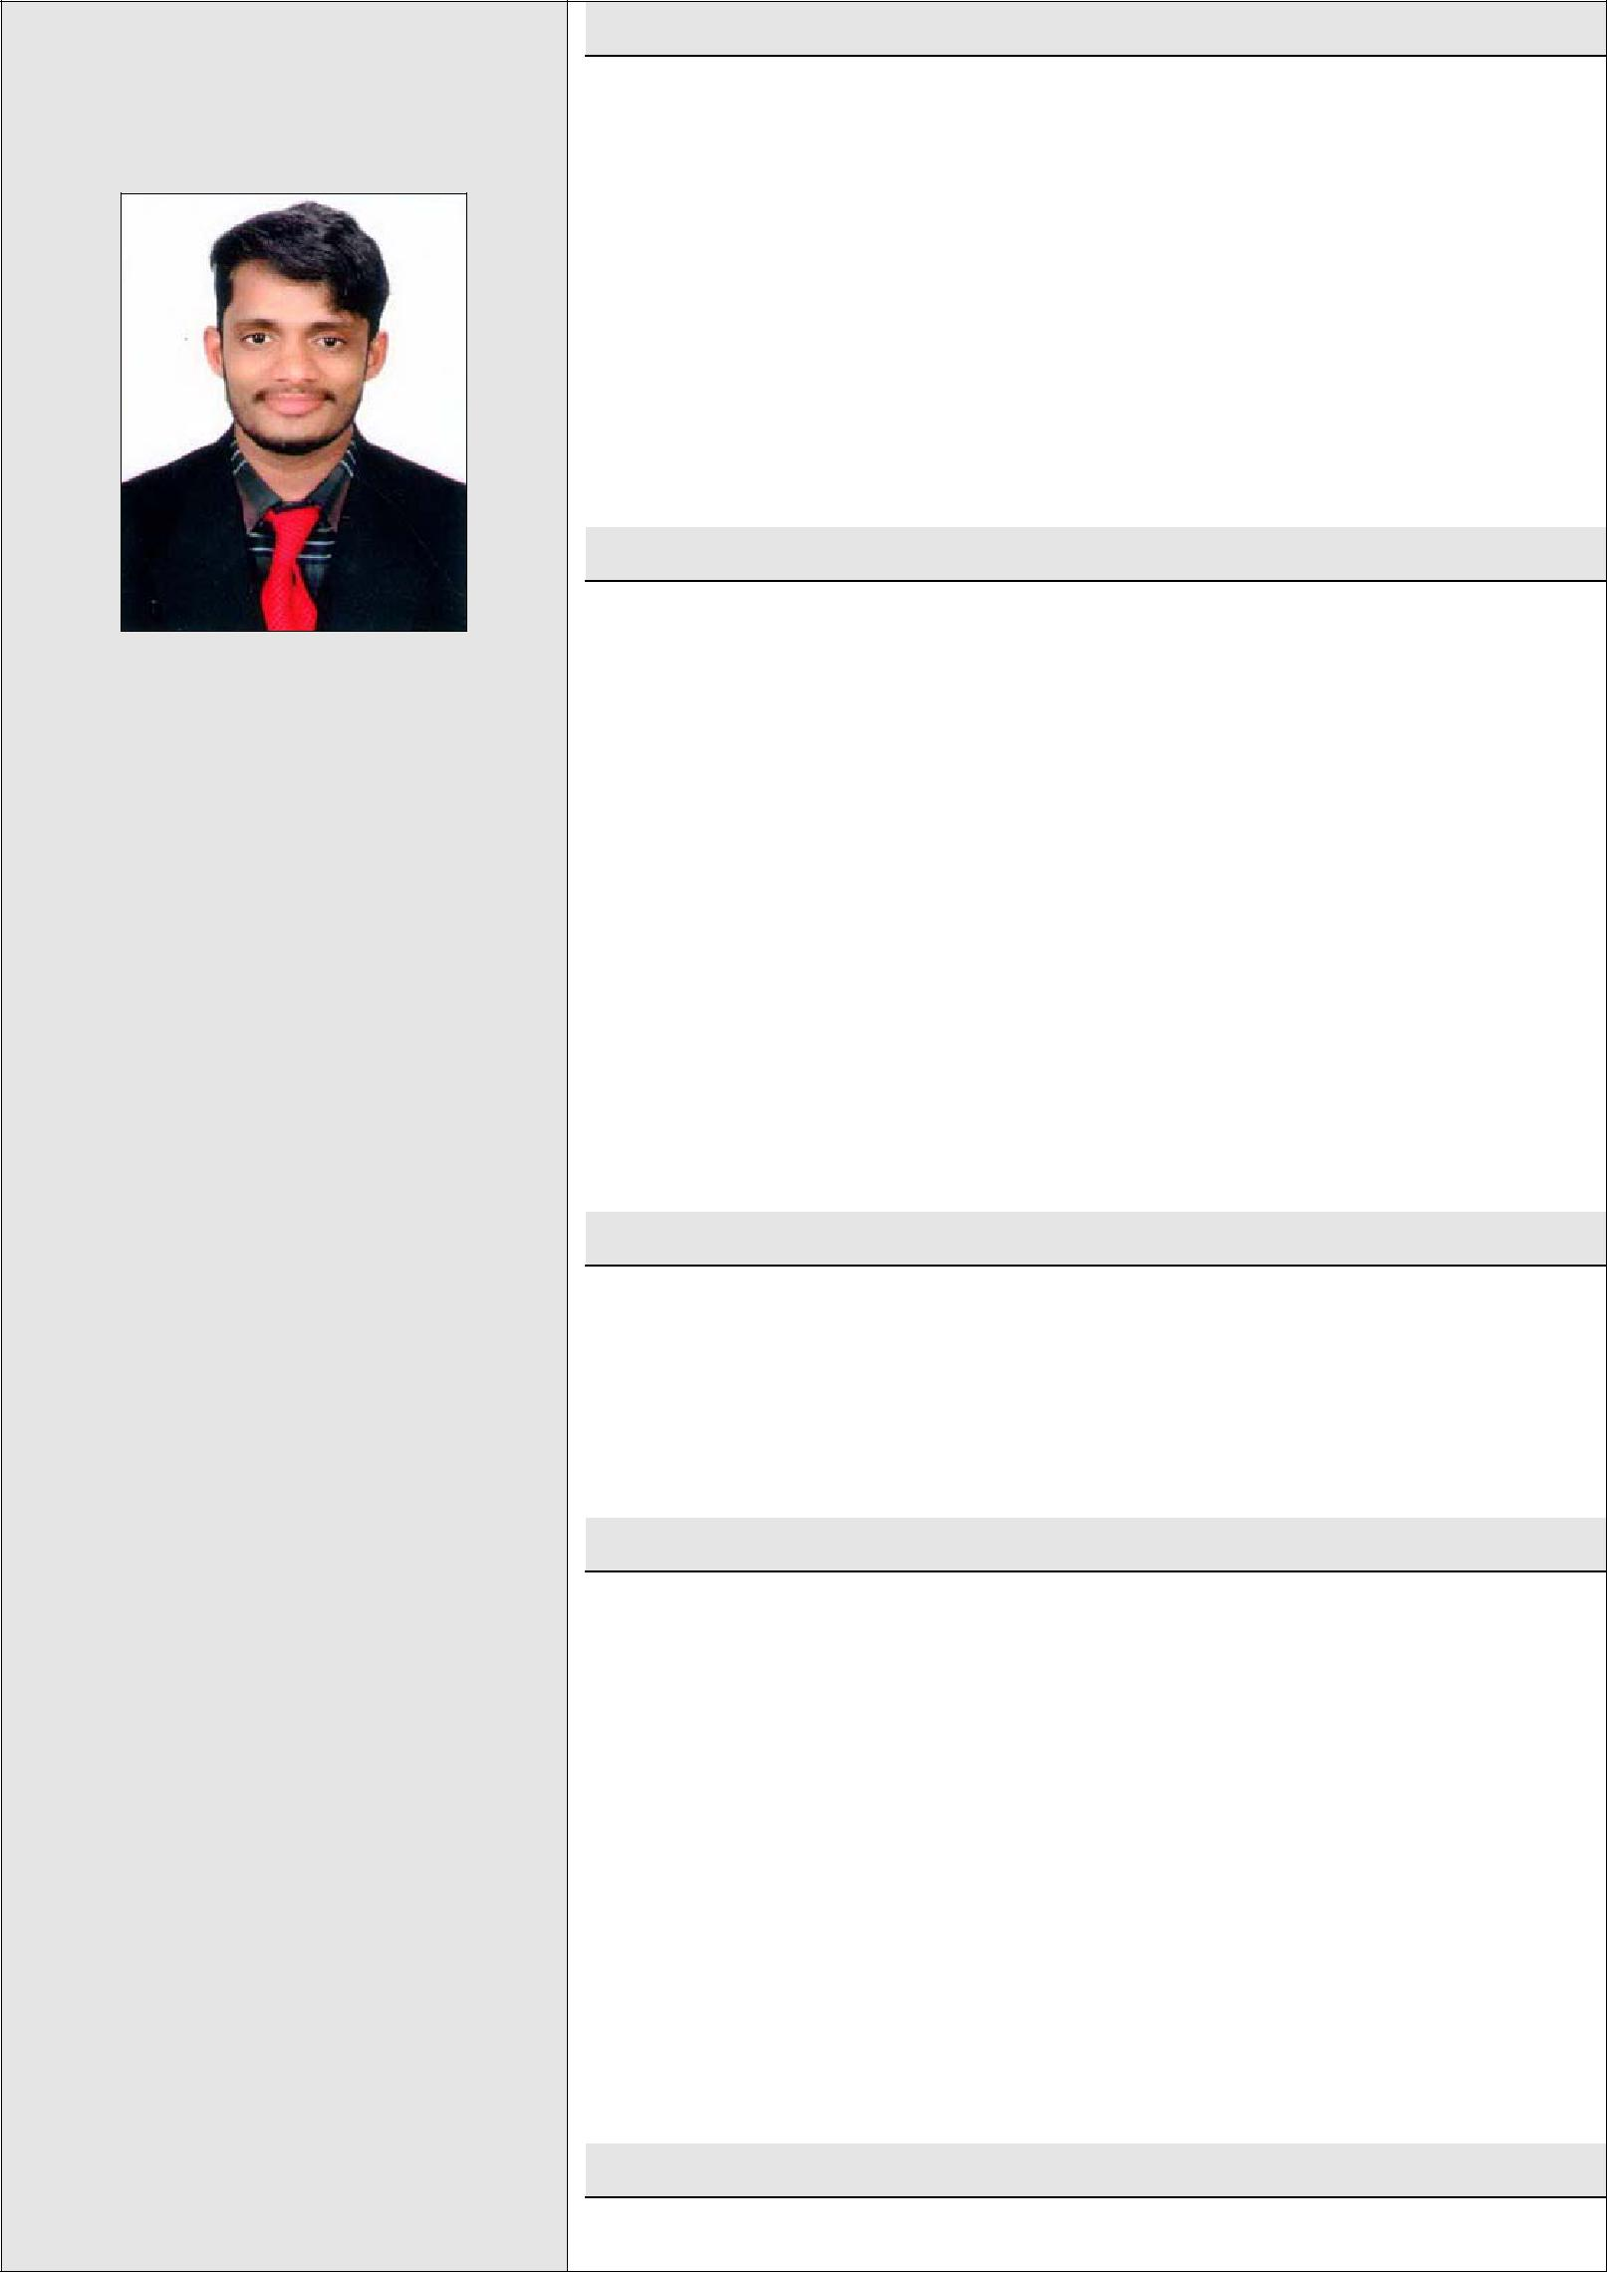

With my certified graduation and experienced as a professional, I am confident enough that I can give my best, as Automobile Technician / Service advisor and any job in any automobile/mechanical companies, where I will get an opportunity to serve. And I will be a part of progressive organization that gives a scope to enhance my knowledge and utilizing my skills towards the growth of the organization.

Educational Qualification:

- Diploma in Automobile Engineering (2014-17) - Successfully completed with First Class in SNMP College, Moodbidri.

- Graduate Degree in B.A (2011-2014) Successfully completed with First Class at Pompe College Aikala.

- Diploma in Computer Application.

- P.U.C (2009-2011) - Successfully completed in V V Pre

University College Mundkur.

- S.S.L.C (2009) - Successfully completed in V V Pre

University college Mundkur.

Work Experience:

- Served as ”Technician (Assembly line)” in Taffe Multi

National Company, Bangalore.

- Served as ”Technician (Production line)” in Borg

Warner Multi National company, Chennai.

Academic Projects :

- Project 1: Engine Reassembling

Organization: SNMP College, Moodbidri

Description: Over hauling piston head, Stroke, Cylinder Block, Gasket, Water pump.

- Project 2: Air assisted mechanical vehicle

Organization: SNMP college, Moodbidri

Description: Preparing Air assisted mechanical machine by using simple materials like motor, battery, air cylinder, rotor pump and solenoid, sensor, air receiver etc…

Computer skills:

- Diploma in computer application (DCA)

Key strength:

- Self-motivated and ability to take the initiative.

- Quick learner, Keen to learn and improve skills.

- Able to take responsibility.

- Problem solving skill.

- Punctuality and time keeping.

Hobbies:

- Listening to music, Reading fiction and nonfiction books.

- Playing cricket, volleyball.

Declaration:

I hereby declare that the above information given by me, are true to the best of my knowledge and belief.

Yours faithfully,

Surendra

