NILESH
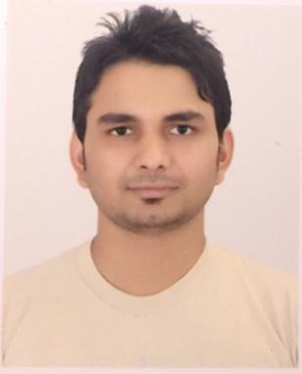

CONTACT

Civil Engineer

I am a highly dynamic and enthusiastic person by nature always seeking a challenging position in a reputed organization for my professional growth. Capable to work independently with minimum supervision and committed for providing high quality service to every work with focus on health, safety and environmental issues. Professional, capable and motivated individual who consistently perform in challenging circumstances.

EMAIL ADDRESS

Nilesh.383222@2freemail.com Bur Dubai, Dubai

EDUCATION

2009 School Leaving Certificate (SLC)

- V.S.Niketan Higher Secondary School
2011 Higher Secondary Level (XI &XII)

- V.S.Niketan Higher Secondary School
2016 B. Tech (CIVIL Engineering)

-Aditya Engineering College Affiliated to: Jawarlal Nehru Technological University, Kakinada, India

WORK EXPERIENCE

District coordinator

Environmental Culture Agriculture Research

Development Society Nepal(ECARDS Nepal)

Kathmandu,Nepal

July 2016 to November 2017

WASH Engineer

Community Development and Environment Conservation Forum(CDECF) Sindhupalchok,Nepal

December 2017 to June 2018

KEY ACHIEVEMENTS

- Surveyed, designed and estimated 3 large projects in CDECF and 8 sub- projects in ECARDS Nepal with its implementation and completion.

- Supervised 6 underlying office employees (WASH Officer, Overseer, Sub-overseer, Technician and Social mobilizers) and also in-house, external contractors and sub-contractors.
- Provided guidelines to field team and led team throughout the work.

- Attended meetings and discussed project details with clients, contractors, asset owners and stakeholders.

- Inspected inventories and prepared orders for CIVIL projects and refractory materials in line with budgeted figures averaging Rs.30 millions.

- Worked closely with the organizational bodies and field staffs for follow up and evaluation, and presented reports to organization.

SKILLS

- Software experiences: - AutoCAD and SOFTWEL (water supply system design software)

  - Computer skills (Microsoft Office, Spreadsheets, PowerPoint, Microsoft Access, web and social skills, Emails, etc.)

  - Complex data interpretation (trigonometry, Geometry)

