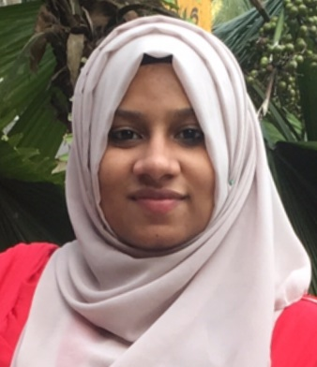
BASIYATH
B. Tech – Computer Science
Basiyath.383221@2freemail.com

Scaling new heights of success and leave a new mark of excellence in assignments which involve analytical capabilities and professional growth.
OBJECTIVE

Self-motivated and hardworking fresher seeking for an opportunity to work in a challenging environment to prove my skills and utilize my knowledge & intelligence in the growth of the organization.
AREAS OF EXPERTISE

Web Development

Product Management

Project Management

Client Servicing

Team Management
PROFILE SUMMARY
- Skilled in:
- Developing high-volume & low-latency applications for mission-critical systems and delivering high-availability & performance
- Assuring that the designs are in compliance with specifications
- Creating the releases of software components
- Supporting continuous improvement by investigating alternatives & technologies
ORGANISATIONAL EXPERIENCE
May’05-Oct’06: E-Way IT Solutions Pvt. Ltd, location as Programmer/Software Engineer

FUNCTIONAL SKILLS
- Completing product development as per requirements, schedules & activities
- Handling java development including design & troubleshooting of applications
- Monitoring service-based project progress & outstanding issues and ensuring the quality
- Preparing monthly dashboard, project health check metrics and weekly
- Designing & developing user interfaces to internet by setting expectations
- Completing programming using languages & software products; conducting tests
- Working with onsite client to track status & issues in offshore development mode
TECHNICAL SKILLS

- Coding skills: C, C++, Java, HTML, Angular, JavaScript, CSS, PHP

- Operating Systems: Windows 7,10 & Linux

- Database: MySQL, MSSQL

- Development Environments: NetBeans IDE, Android Studio, MS Visual studio2012

- Tools: Android SDK Platform Tools, Wireshark Sniffer, XAMPP

- Framework: Spring

PROJECTS

- Software Developer Team Lead
  - ENETRA
- Application is used to eavesdrop what actions had done by users with android applications
- Used MySQL Database
- Used software’s like Wireshark & XAMPP
- Used PhpMyAdmin
- Worked withNetBeans IDE
- Worked with different form functionalities using JavaScript & jQuery
- Android Developer Team Lead
  - Droid Detector
- Application is used for helping users to detect malwares in android applications
- Used MySQL Database
- Worked with Android Studio
- Web Developer Team Lead
  - Smart Student Diary
    - Used to create distributed e-learning environment for students
    - Used MVC Architectural pattern
    - Used MySQL Database
    - Worked withMS visual studio
    - Six-page application using ASP.NET
EDUCATION

- B. Tech (Computer Science) form Calicut University, in 2017 with GPA 7.2
CERTIFICATION

- Techienest certified workshop on Ethical Hacking & Cyber Security
PERSONAL DETAILS
Date of Birth: 1st Sep 1994
Address: Kerala, India
Languages Known: English, Hindi
Visa Expire: On September 11
DECLARATION

I hereby declare that the above details mentioned are true to best of my knowledge and belief.

