EMAIL ID: vinoy.383238@2freemail.com

VINOY
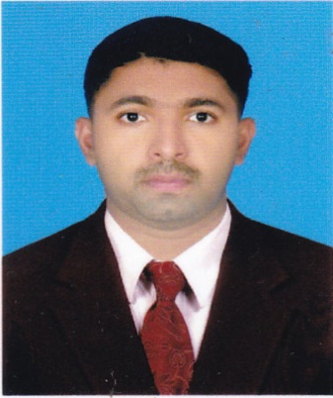
CAREER OBJECTIVE
Seeking a challenging position suitable to my qualification and experience within a competitive environment where I can emphasize my strengths, persistence and dedication that allows utilization of my acquired skills and abilities coupled with my determination to accomplish shared goals of both, the organization and myself.
WORK EXPERIENCE OMAN
SAUD BAHWAN AUTOMOTIVE LLC 2012 to2016
Worked as Technician, Time Scheduler, Service Advisor and RAS Inspector (Road Assurance Safety) for 3years and 6 months in Toyota service.
WORK EXPERIENCE BAHARIN
Workedas a Service in charge at Al Kobaisi Motors 2017( 8 month)
WORK EXPERIENCE INDIA
- worked as a Diesel Mechanic at SHAKTI AUTOMOBILESFrom 07.10.2007 to 12.11.2008 (TATA Vehicle Service Centre Bus and truck)

- worked as Technician at KVR VehiclesFrom 01.05.2009 to 20.02.2010 (TATA Vehicle Service Centre passanger car) Kannur, Kerala

- worked as Technician at SML ISUZU From 30.08.2010 to 10.12.2012 (SWARAJ MAZDA Service Centre)

ROLES AND RESPONSIBILITIES
Technician
- Mechanical assembly, oil and lube changes, preventive maintenance inspections, diagnose cause of complaint using various tools and diagnostic testing procedures.
- Specialise in engine repair maintenance and overhaul.
- Follow repair checklist to ensure all repairs are completed accurately.

Service Advisor
- Record Customer / Vehicle Information: Update repairs, history and fleet account information using company management software.
- Handling customer complaints.
- Determining the repairs to be carried out.
- Preparing estimate for total cost of repairs, consult customers and close on repair sale.
Time Scheduler
- Coordinate workloads amongst other technicians and supervise all testing and repairs.

STRENGTH AND EXPERTISE
- Hard working
- Sincere
- Easily adaptable to new concepts and ideas
- Self-motivated and Team oriented professional with good communication skills
- Decision making
TECHNICAL SKILLS
- Microsoft Word and Excel
- SAP
- AutoCAD
- Diploma in Computer Application
ACADAMIC QUALIFICATION
- Diploma in Automobile Engineering 2005-2007
- S.S.L.C Board of Public Examination 2005
PERSONAL DETAILS
- Date of Birth : 30/12/1989
- Languages Known : English, Arabic, Hindi, Malayalam and Tamil.

DECLARATION
I here declare that the information and facts stated above are true and correct to the best of my knowledge and belief.

