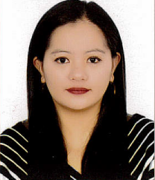
Annabelle

Annabelle.383288@2freemail.com

Objective:

To succeed in an environment of growth and excellence and earn a job which provides me job satisfaction and self development and help me achieve personal as well as organizational goals.

Career Profile:

- Making Medical reports for Doctor,clients and Insurance companies
- Taking approvals for different medical procedures to be done
- Making Invoices,General Statements with regards to the Insurance that was sent and approved by the Insurance.
- Receiving Cheques and Making Staments for the payment received from different Insurance Companies.
- Filling up documents and sending it to the Insurance and client
- Dealing with different Insurance Companies
- Assess patient health problems and needs, develop and implement nursing care plans, and maintain medical records
- Answer call and giving appointments.
- Provides Quality Patient care
- Sound Ability to help, support and resolve the queries and problems of the patient and their families.
- Able to teach English language to different nationalities using all the areas of English such as reading,listening,vocabularies and conversation (free talking).
- Knowledge in purchasing products and checking/inventory of products available.

Personal Information

Birth Place: La Trinidad, Benguet, Philippines
Date of Birth: August 4, 1986
Civil Status: Single
Nationality: Filipino
Visa Status: Employment Visa
Languages Known ( English, Tagalog)

Professional Experience

Insurance Coordinator/Receptionist
Eastern Clinical laboratories (March 6,2017- present)
1st floor 105 Elite Building, Al Barsha Dubai UAE

- Take approval for Laboratory test
- Using Eclaims sytem in submitting approved test and resubmission for rejected claims
- Register Client details
- Released laboratory reports to clients and different providers
- Makes reports for Newborn screening
- Answer queries regarding Insurance and Laboratory test
- Making invoices for payments from individual clients
- Communicate with outsource laboratory regarding reports
- Prepare monthly invoice for Insurance and clinics
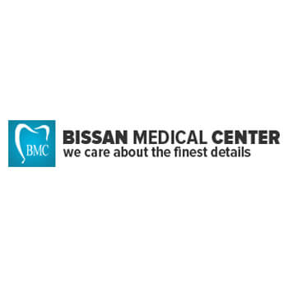
- Monitor sample pick up and prepare proforma invoice for pick up.

Insurance Coordinator/Clerk/Archives
Bissan Medical Centre ( May 2014-February 28,2017)
Flat 103 Golden Tower Building,Buhairah Corniche, Sharjah UAE

- Taking approvals for the client’s Insurance
- Submit Insurance claims through eclaims system and resubmission for rejected claims.
- Explain client’s Insurance benefits and prepare documents for payments
- Makes Invoices and Statements
- Making Medical/Orthodontics and referral letters
- Keeping Important Files/Documents
- Making calls and answer queries with regards to different Insurance Company.
- Making Sick leave reports for Patients and staff.
- Making reports for payments and cheques received from Insurance company.
- Communicating with different Insurance companies for empanelment and new systems.

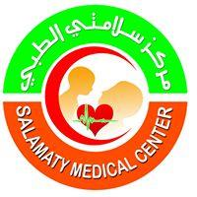
Clinic Nurse/Patient Receptionist ( May 2012- February 2014 )
Salamaty Medical Center
Al Dhaid, Sharjah UAE

- Vital signs taking and recording
- Administration of Medicines such as oral and Parenteral medications (Different injection routes)
- Intravenous Insertion
- Collection of specimen and sending to laboratory
- Assisting in Dental procedures
- Assist in Fractional Laser and Beauty procedures
- Making Laser hair removal
- Equipment sterilization
- Assist in circumcision
- Answer telephone calls and answer clients inquiries
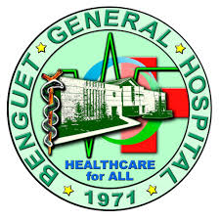

Staff Nurse ( January 2012- April 2012)
Benguet General Hospital
Km.5 La Trinidad Benguet, Philippines

- Assist with the Admittance and discharge of patients.
- Performs clinical task according to hospital policies.
- Monitor Vital signs, intake and output and recording
- Assess patients status and notify Physicians of Clinical changes.
- Assist patients and Family members in the education of health care needs.
- Gives Immunization to newborn.
- Gives oral and Parenteral medications and Intravenous Insertion.
- Wound Cleaning and Dressing
- Responsible for the Accurate Documentation followed by medicine administration.
- Responsible on patients all over health care needs
- Assisting Doctors in Physical Assesment
- Perform Nasogastric and Jejunostomy Feeding and Tracheal Intubation.
- Working of instruments such as pulse oximeter,, Nebulizer, oxygen apparatus, suction apparatus, -Glucometer, ECG Machines
- Charting

Online English Teacher (May 2011-January 2012)
Megastudy English
Jose De leon Building. Upper Session road, Baguio city, Philippines

- Taught Korean Nationalities about English language which includes proper reading and pronunciation of words
- Making/Forming sentences using Vocabulary words and proper usage of Grammar through online basis.
- Free Talking to enhance communication skills.

English as Second language Teacher (ESL) (January 2010-September 2010)
Pines Montessori School
Outlook drive, Baguio city, Philippines

- Served as an English Teacher who introduced and tackles all the areas of English Language to Korean Nationalities which includes Vocabularies, Grammar, Reading Comprehension, Proper Writing, Active Listening and Free talking.
- classroom management;
- planning, preparing and delivering lessons to a range of classes and age groups;
- preparing and setting tests, examination papers, and exercises;
- marking and providing appropriate feedback on oral and written work;
- organising and getting involved in social and cultural activities such as sports competitions,
- freelance teaching on a one-to-one basis

Saleslady/Cashier (March 2010- August 2010)
Jaira’s Souvenir and Crafts
Mile-hi Center, Camp John hay, Baguio City

- Selling different local products to local and foreign people
- Provide information and guidance regarding the product being purchased
- Assisting customers in locating local products to ensure that they are satisfied with it.
- Cash collection,taking money and giving change to customers ensuring that the total is correct.
- Monitor how much money is there when the store opened and how much was earned when the store closed.
- Inventory of products and ordering products which is already unavailable.

Professional License

Professional Regulation Commission (PRC)
Registration no: 0614577
Date of Issue: March 25,2010
Place of Issue: Baguio City, Philippines
Expiry Date: August 4, 2020

Educational Background

University/College
Pines City Colleges
Magsaysay Avenue ,Baguio City, Philippines
Bachelor of Science in Nursing
S.Y 2003-2009

High School/Secondary
Rizal Annex (Baguio City National High School (BCNHS)
Gibraltar, Baguio City Philippines
S.Y 1999-2003

Elementary
Rizal Elementary School
Gibraltar, Baguio City Philippines
S.Y 1993-1999

Seminars and Trainings Attended

UMO Gold Facial Mask
July 30, 2013
Al Dhaid, Sharjah United Arab Emirates

Electrocardiogram (ECG) Reading, Interpretation and Monitoring: Expectation from Nurses
February 25, 2010
BBCCC Hall, Assumption road, Baguio city Philippines

Skills

Key Skills - Dedicated Registered Nurse that is knowledgeable in providing quality patient care at home, hospital, Nursing home and Private office setting.Credentialed and Background in Obstetric, Pediatric, Surgical and Out Patient Ward.
Knowledge about Standard procedure in Nursing and Health Regulations
Active Listening - Giving full attention to what other people are saying, taking time to understand the points being made, asking questions as appropriate, and not interrupting at inappropriate times.
Reading Comprehension - Understanding written sentences and paragraphs in work related documents.
Computer- Microsoft word, Office and Internet Researcher.
Communication Skills-Fluent in English Language.

